
Faculty of Management, Sciences and Engineering
School of Computing and Engineering

AI Data Analyst: A Multi-Agent Workflow for Autonomous Data Analysis and Pre-processing
  - Final Year Project Final Report

Radin Mokari | 23054961
Supervisor: Professor Ciprian Daniel Neagu
Date of submission: 29.04.2026

A thesis submitted in part fulfilment of the degree of BSc (Hons) Computer Science

Declaration
The candidate confirms that the work submitted is his own and that appropriate credit has been given where reference has been made to the work of others. The candidate agrees that this report can be electronically checked for plagiarism.

Radin Mokari

Abstract
This report states the design and implementing of a full stack AI-powered web application with a multi-agent system as its backend for automating data analysis and pre-process procedure by addressing the inefficiencies and lack of transparency in traditional manual and AutoML tools. By utilizing CrewAI and Google Gemini API, the proposed system orchestrates to autonomously perform entire data analysis cycle with a dynamic and hierarchical workflow, which includes a manager agent orchestrating cleaning, statistics, EDA, visualisation, feature engineering, class imbalance and reporter agents based on the dataset characteristics and user requirements. A key innovation of this project is the integration of role-specific token budgets to increase computational efficiency, which reducing the high latency and verbosity that often caused by Large Language Model (LLM) systems, and splitting the time-consuming analysis phases into a team of AI agent, that simulates how a normal teamwork. The outcome of the project shows an auditable and transparent process which generates a technical markdown reports and visualizations through the execution of Python scripts, which states a stable and scalable base for automating data analysis operations. The source code of the implemented project can be accessed via the following GitHub repository:
GitHub - Radin-Mokari/crewai-data-analysis at Final_Version · GitHub
Contents
Abstract 3
1. Introduction 7
1.1. Project Description 7
1.2. Aims and Objectives 7
1.3. Novelty and Challenges 8
1.4. Programme Alignment and Learning Outcomes 8
1.5. Report Overview 8
2. Literature Review 9
2.1. The Evolution toward Agentic AI 9
2.2. Theoretical Foundations of Multi-Agent Systems 9
2.3. Orchestration Frameworks: The Role of CrewAI 10
2.4. Domain Application: Automating Data Science Pipelines 10
2.5. Cognitive Engine Evaluation: Gemini API 11
2.6. Optimization: Token Efficiency and Codified Reasoning 12
2.7. Human-Agent Interaction & UI/UX 13
2.8. Serving Infrastructure 13
2.9. Domain-Specific Protocols 13
3. Requirements and Analysis 14
3.1. Requirements 14
3.1.1. Functional Requirements 14
3.1.2. Non-functional requirements 16
3.2. Analysis 18
3.3. Methodology 18
3.4. Approach 20
4. Design, Implementation and Testing 20
4.1. Design 20
4.1.1. System Design 20
4.1.2. Hierarchical Architecture 22
4.1.3. Harness Engineering Layers 27
4.1.4. Session Architecture 32
4.1.5. Execution Layer 33
4.1.6. State Validation 33
4.1.7. Prompt Strategies 34
4.1.8. ReAct Loop 36
4.1.9. Retry, Error Detection & Rate Limiting 36
4.1.10. Persistence & Artifacts 39
4.2. Implementation 40
4.2.1. Stateful Tool – PythonSessionTool 40
4.2.2. Specialist Construction 40
4.2.3. Manager Decision Call 41
4.2.4. Orchestrator Single Turn 41
4.2.5. SSE Streaming & Log Channel 42
4.2.6. Karnel Snapshots 43
4.2.7. FastAPI Surface 43
4.3. Testing 44
4.3.1. UI Screenshots 44
4.3.2. Performance Testing with Real-word Datasets 47
4.3.3. Errors & Debugging 48
5. Results and Discussions 49
5.1. Strengths 49
5.2. Limitations 49
6. Legal, Social, Ethical and Professional (LSEP) Issues 49
6.1. Legal Issues 49
6.1.1. Data Protection and Privacy (GDPR) 49
6.1.2. Google Gemini Paid Tier & Data Sovereignty 50
6.1.3. The European AI Act (EU AI Act) 50
6.2. Social Issues 50
6.2.1. Impact on Employment and Automation 50
6.2.2. Accessibility and the Digital Divide 50
6.3. Ethical Issues 50
6.3.1. Hallucinations and Accuracy 50
6.3.2. Bias and Fairness 50
6.4. Professional Issues 51
6.4.1. Software Quality and Reliability 51
6.4.2. Code Safety and Security 51
Conclusion and Future Work 51
Bibliography 52
Appendices 56

Introduction
Within the contemporary domain of data-centric strategic planning, enterprises face rapidly growing data volumes, demanding rapid evaluation to inform crucial strategic initiatives. To clarify this argument, conventional data science pipelines are often constrained by manual bottlenecks, given that foundational processes such as data sanitization, exploratory data analysis (EDA), and report generation persist as labour-intensive, protracted, and highly unstable operations. Such inefficiencies delay investigation and postpone insight acquisition, which underscores an essential need for cognitive automation frameworks capable of autonomously orchestrating these workflows for guaranteed scalability and operational efficiency. (Chirag and Nagra 2025).
Despite the advancements in automation, traditional approaches and existing Automated Machine Learning (AutoML) tools, like TPOT and Auto-Sklearn, frequently operate as monolithic "black boxes" that suffer from limited interpretability, modularity, and adaptability to dynamic real-world workflows (Chirag and Nagra 2025). Recent LLM-based systems like AutoGPT and CrewAI expose limitations in operational efficiency and reliability while they show guarantee in autonomous dynamic task delegation and reasoning (Chirag and Nagra 2025). Specifically, current prompting strategies often result in excessive verbosity and high latency, failing to optimize for token efficiency or cost (Yang et al. 2025; Jiang et al. 2023).
This project focuses on covering these gaps through the design and implementation of a prototype of a multi-agent workflow that automates a comprehensive data analysis process.

Project Description
This project establishes a transparent, multi-agent mechanism which facilitates automated data analysis by utilizing CrewAI and the Google Gemini API. A structured team of 7 agents (Cleaning, EDA, Statistics, Visualization, Feature Engineering, Class Imbalance, Reporter), orchestrated by a manager through the explicit execution of Python scripts, documented via comprehensive logging. Upon initialization, the user simply adds a CSV file within the root directory to activate the dataset brief mechanism, the workflow validates all dependencies and input, then proceeds through each analysis phase by applying intelligent cleaning and transformation strategies that are tailored to the input dataset and user prompt. The platform yields verifiable analysis results, establishing a confirmed, scalable basis for further decisions and developments. The user interface provides a chat session per application run alongside chain-of-thought after each query, a workflow log trace, a Python code editor, and downloadable analysis results as reports and images for generated visualizations.

Aims and Objectives
As stated earlier, the project aims to automate data analysis and preparation through a transparent, cost-efficient multi-agent system emphasizing data quality and auditability. Its main objectives are:
Cost efficiency: Assigning role-specific token budgets and use a low-cost LLM to reduce processing costs.
Validation-driven cleaning and transformation: Generating structured validation reports on missingness, outliers, and type issues to guide data cleaning, and applying transformation steps by feature engineering and balancing target class (if applicable).
Transparent workflow: Building an automated and dynamic workflow that logs intermediate LLM decisions for easy inspection and auditing.

Novelty and Challenges
The system’s novelty lies in its token stratification across agents, utilising domain-specific specialist agents for each task, and building a fully dynamic hierarchical workflow that simulates how a normal data science team with a leader operate. Unlike LAMBDA and Data Interpreter, which focus on context length and debugging but lack token control and semantic validation (Maojun et al., 2025; Hong et al., 2024), this project manages verbosity with role-specific token limits. It uses a low-cost LLM and ten specialized agents for concise outputs, supported by a dynamic validation-cleaning process that responds to actual issues rather than fixed rules. On the other hand, while other similar platforms either use fewer generalist agents or solve problems with agentic brainstorming like AutoGen, the purposed project utilises a custom, hierarchical and dynamic workflow, which lets the agents to work like a real team.
It is well-known that novelty brings challenge as well. Regarding building a cost-efficient workflow, it is crucial to choose effective token budgets for different level of agents. From one side, aggressive limit can save cost but from the other side, it increases the possibility of cutting important context. Also, choosing the right LLM model to interpret validation summaries and pick suitable cleaning strategies is another key challenge. On the other hand, while other AI platforms show the CoT of the LLMs, this project is targeting a CoT for the agentic workflow, which brings its own problems. And lastly, depending on the objectives of the project, additional metrics would be required to measure token efficiency and data-quality handling since current evaluations focus on task success and accuracy.

Programme Alignment and Learning Outcomes
This project aligning with core Computer Science learning outcomes from across the programme modules. AI and ML drive the multi-agent supervisor, and the data-preparation work its specialists perform (feature engineering, scaling, class-imbalance, statistical testing). Software engineering and enterprise programming shape the layered architecture, classical design patterns (Mediator, Strategy, Observer, Memento), and typed API contracts (Pydantic, TypeScript). Concurrent and distributed systems and large-scale data-driven applications module outcomes appear in the FastAPI client-server split, the asyncio.Lock and worker-thread / Queue bridge that powers Server-Sent Events, sliding-window memory, and crash-safe checkpointing. And database systems principles inform the append-only JSONL with fsync, columnar Parquet snapshots, and versioned schema of the persistence layer. Overall, it translates theoretical computer science into a scalable, intelligent software solution for automated data analysis.

Report Overview
The report is organised into five chapters: a literature review, requirements and analysis, design and implementation with testing, results and discussion, and a conclusion.
The literature review covers the shift from generative to agentic AI, multi-agent systems, advanced orchestration frameworks such as CrewAI, applications in automated data science pipelines, LLM capabilities and prompting for cost-efficient workflows, context and memory engineering, resilience and harness engineering, human-agent interaction, domain specific protocols, and serving infrastructure.
Requirements and analysis define functional and non-functional requirements, present a use case diagram for user-application interaction, and outline the semester 1 and 2 work plan.
Design, implementation and testing describe the application’s technical design, project structure, technology stack, configurations, scripts, and how the implementation follows the planned design principles. Then the testing phase focuses on human-agent interaction by testing the workflow with different datasets.
Then a comprehensive Legal, Social, Ethical and Professional Issues section is conducted though research about the impact of the project.
The results and discussion chapter summarises strengths and limitations, while the conclusion synthesises the proposed solution, implementation, and key findings.

Literature Review

The Evolution toward Agentic AI
The operational paradigm within the Artificial Intelligence sector is progressing from Generative Models, primarily defined by content synthesis, toward Agentic AI, which leverages capacity for autonomous reasoning, multi-step planning, and executive protocols (Abou Ali et al. 2025). While Generative AI focuses on content generation, the Agentic system establishes inherent functional self-governance, permitting apparatuses to discern environmental variables, formulate strategic heuristics, and implement involved execution protocols absent external oversight (Joshi 2025). This architectural migration from "Copilot" models (leveraging human support) toward "Autopilot" frameworks (full operational autonomy) is pivotal for corporate optimization, since industry analysis confirms specialized agent systems yield 50-80% effectiveness improvements in data-intensive tasks compared to traditional methodologies (Joshi 2025). This review contextualizes the implementation of a multi-agent data analysis workflow by examining the theoretical foundations of Multi-Agent Systems (MAS), the specific orchestration capabilities of CrewAI, the cognitive performance of the Gemini ecosystem, and emerging techniques for optimization.

Theoretical Foundations of Multi-Agent Systems
The well-established theory of Multi-Agent Systems (MAS), defined as loosely linked networks of problem solvers who collaborate to solve problems beyond the powers of a single entity, is the foundation for the implementation of autonomous systems. Traditionally, MAS architectures have concentrating on properties such as autonomy, coordination, and fault tolerance, that agents are computational entities capable of detecting parameters and performing actions to achieve specific goals (Maldonado et al. 2024).
Current research proposes a "Framework-Components in Multi-Agent System" (FC-MAS) model, which abstracts these systems into layers including physical networks, synchronization, and network controllers (Maldonado et al. 2024). A critical advantage of MAS in data science is the ability to decompose complex global goals into manageable local tasks. This decomposition allows for "orchestrated intelligence," where a central coordinator or hierarchical structure manages agent communication and task allocation, ensuring convergence toward a global objective such as model accuracy or data integrity (Maldonado et al. 2024).
The existing research about agent resilience has progressed past basic retry loops because it now enables systems to access "Inspector Mode" which lets agents perform deep traceback analysis to understand their errors (Liu, Abulawi, et al. 2026). The modern architectural designs of VIGIL, AgentFixer, and Tuning Agents which serve specific purposes enable systems to automatically process execution logs and Python tracebacks and multi-agent behavioural traces for advanced root cause analysis (Mulian et al. 2026; Liu, Abulawi, et al. 2026; Cruz 2025). Agents use error stream analysis to identify specific logical errors and schema mismatches which enable them to create precise code patches and request system changes for actual self-repair through meta-procedural methods (Chen, Wang, et al. 2025; Cruz 2025).

Orchestration Frameworks: The Role of CrewAI
To implement agentic behaviours effectively, robust orchestration frameworks are required. The current applications involve diverse tools like LangGraph for stateful, low-level control, and AutoGen for conversational agent systems. Among these, a prominent framework specifically designed for orchestrating collaborative, role-based multi-agent workflows has occurred called CrewAI (Joshi 2025).
Academic research highlights that the CrewAI platform is tailored to support high-end development requirements demanding structured teamwork and accurate distribution of responsibilities among the professionals, in contrast to generalized structural methodologies. The system allows the designation of clear-cut professional roles, setting up individual agents in terms of objectives and foundational contexts, which makes the replication of organizational dynamics possible. According to the comparison evaluations, while the toolsets such as LangGraph provide the user with a very fine control over the changes in programmatic state, CrewAI is the one who handles the cases of rapid operational prototyping and complex objectives managed through procedural execution very well (Joshi 2025). This consequently makes it highly applicable to data science pipelines where the distinct roles of data cleaning, feature engineering, and performance evaluation, among others, need to work either in a sequential or hierarchical manner (Chirag and Nagra 2025).

Domain Application: Automating Data Science Pipelines
for Agentic AI, the automation of data science workflows represents a high-value application. Traditional AutoML tools mostly function with limited interpretability. Recent studies suggest decomposing the data science pipeline into specialized agents by modular, multi-agent frameworks. For instance, a reduction in development time by approximately 60% and error rates by 35% is discovered compared to manual workflows when a framework utilizing agents for Data Cleaning, EDA, Feature Engineering, and Modelling (Chirag and Nagra 2025).
Within these system designs, a primary "Task Dispatcher," often designated as the "Central Coordinator," delegates specific functions to specialized components. For example, the identification of missing data and the detection of anomalous points are managed by a Data Cleansing component, whereas algorithmic selection and the refinement of hyperparameters are executed by a separate Modeling Entity. This modularity not only enhances efficiency but also promotes transparency, as agents can trigger feedback loops to retrain models if evaluation metrics fall below defined thresholds. To clarify this argument, the embedding of foundational Large Language Models (LLMs) within these entities specifically enables the creation of articulated insights and formal documentation, thereby improving crucial communication across stakeholder groups (Chirag and Nagra 2025).
Researchers have moved from traditional hierarchical systems which used agents as fixed "task dispatchers" toward systems which employ non-linear adaptive orchestration methods (Yang, Feng, et al. 2025; Darshan 2026). Modern architectural systems use autonomous goal-directed systems to execute planning processes instead of following pre-set execution patterns and static Directed Acyclic Graphs (DAGs) (Darshan 2026). The system uses a central supervisor who operates as a stateful runtime operator according to Ran et al. 2026. The system evaluates environmental feedback together with kernel-level state policies to determine the best execution path which provides protection through self-healing and context-aware task execution capabilities (Darshan 2026; Anis Koubaa 2025).

Cognitive Engine Evaluation: Gemini API
The reasoning skills of the underlying LLM have a significant impact on how well an agentic process works. Designed to interpret and link data from several modalities, such as text, code, and pictures, the Gemini family of models marks a major leap in multimodal AI (Islam and Ahmed 2024).
According to performance tests, the Gemini framework (especially, the Ultra and Pro models) performs similarly to GPT-4 when it comes to programming and analytical tasks (Islam and Ahmed 2024). Although external technical analyses show that Gemini Pro performs differently from GPT-4 or Claude 3.5 Sonnet in certain robotic control or dimensional reasoning parameters, it produces significant proficiency in complex multilingual comprehension and advanced multimodal processing optimisation (Sobo et al. 2024; Islam and Ahmed 2024). Notably, through methods like Retrieval Augmented Generation (RAG), Gemini's integration with development ecosystems facilitates the retrieval of factually grounded results, and its design enables effective serving at scal (Islam and Ahmed 2024). Also, Recent research into collaborative agentic systems, such as the CoDA framework, highlights that Gemini 2.5-Flash is specifically designed for multi-agent workflows; it maintains almost 98% of the overall performance of the larger "Pro" model while providing the low latency and high speed required for real-time sequential operations. The Gemini models outperform Claude-4-Sonnet in terms of code execution resilience under high-context loads, whereas Sonnet saw a 4.3% performance decline because of decreased dependability while running sophisticated, agent-generated code (Chen et al. 2025). For data analysis tasks involving tabular datasets, Gemini's ability to interpret complex instructions and generate code makes it a viable cognitive engine for autonomous agents.
Looking at the performance chart below, Gemini 2.5 Flash Preview achieves the highest pass rate (44.94%) among all tested LLMs, outperforming Claude Opus 4, Sonnet 4, and Llama models in automated multi-agent reasoning tasks:
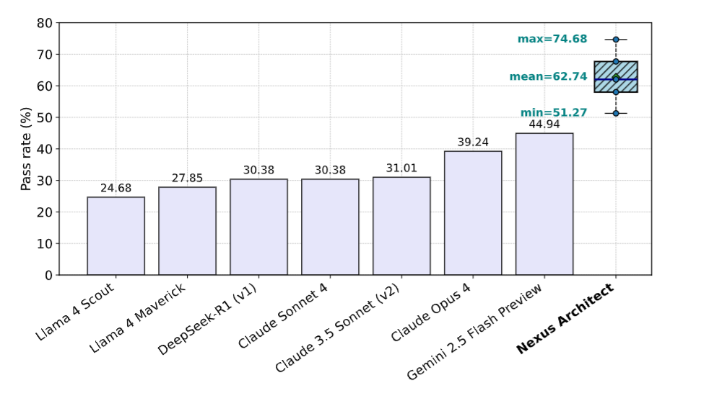
Figure 1 - Performance Comparison of LLMs in Multi-Agent Workflows (Sami et al. 2025)
Additionally, as shown in the Figure 2, Gemini-2.0-Flash shows only 0.8-3.0% improvement when using multi-agent systems versus single-agent, thus it's already highly capable without expensive multi-agent overhead. This means strong baseline performance makes Gemini 2.5-Flash cost-effective for multi-agent workflows.
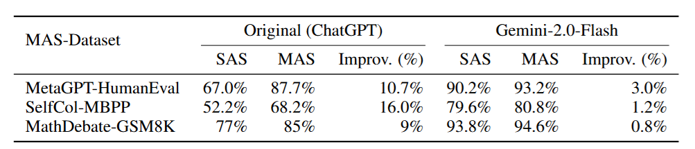
Figure 2 - Multi-Agent Benefits Diminish with Stronger Models (Gao et al. 2025)

Optimization: Token Efficiency and Codified Reasoning
the computational cost and latency that caused by verbose communication between agents is a vital challenge in deploying LLM-based multi-agent workflows. Recent literature proposes a solution, where agent interactions are structured as pseudocode rather than natural language. This approach is called "Codified Prompting" and has been shown to reduce token usage by approximately 55–87% while improving plan adherence and success rates in complex reasoning benchmarks (Yang et al. 2025).
Additionally, prompt compression techniques such as LLMLingua utilize coarse-to-fine compression algorithms to reduce the length of prompts by up to 20x while maintaining semantic integrity. These optimization strategies are essential for scaling data analysis workflows, where agents must process large context windows containing dataset schemas, sample rows, and execution logs without exceeding token limits or incurring prohibitive costs (Jiang et al. 2023).
Current research shows that fixed context windows experience severe knowledge loss because they lose 80 percent of information when facts disappear from view (Bednárik and Gogolák 2025). The researchers provide a solution to project amnesia which occurs during complex data analysis processes that last for hours across hundreds of execution steps (Guo et al. 2025) by proposing a sliding window method which uses recursive summarization (Bednárik and Gogolák 2025; Hu et al. 2025). The hybrid system combines a fixed sliding window that handles current performance needs with an ongoing rolling summary of earlier user interactions to create a permanent mental mapping system (Bednárik and Gogolák 2025; Hu et al. 2025). The research shows that rolling summarization improves long-term learning of facts because it raises retention rates from 20 percent to 50 percent while creating a unified session experience which avoids extra computing costs and context restrictions and noise buildup that comes with extending historical data (Bednárik and Gogolák 2025; Hu et al. 2025; Liu, Su, et al. 2026).

Human-Agent Interaction & UI/UX
The literature focuses a theoretical shift toward a "shared agency" model in UI/UX, where interactive human-AI co-creation replaces rigid automation. By integrating embedded editors (such as VSCode interfaces) and stateful, shared Python runtimes directly into multi-agent workflows, systems allow developers to seamlessly observe, manually override, or collaboratively extend an agent's ongoing progress within the exact same kernel state (Ran et al. 2026; Chen, Talwalkar, et al. 2025; Grotov and Botov 2025). Concurrently, to combat the "black box" anxiety inherent in autonomous AI, researchers strongly advocate for real-time Chain-of-Thought (CoT) observability (Mehta 2025; İlgen and Hattab 2026). Streaming an agent's internal "thoughts," execution logs, and live tool invocations continuously to the user provides crucial process-time transparency (Alva and Pandey 2026; Raza et al. 2026). Ultimately, coupling this shared-state manual control with real-time cognitive visibility transforms opaque AI operations into verifiable, contestable, and highly trustworthy collaborative processes (İlgen and Hattab 2026; Mehta 2025).

Serving Infrastructure
The current architectures solve the problem of conflicting stochastic agent reasoning and deterministic serving layers through their implementation of Server-Sent Events and their use of asynchronous event-driven streaming (Yuan, Lyu, et al. 2026). The ACP-AGNTCY framework achieves thread safety and session continuity during unpredictable "thinking times" by using explicit Thread Identifiers and streaming continuous lifecycle events instead of keeping monolithic connections open (Yuan, Lyu, et al. 2026). The system uses stateless transport layers together with permanent producer-consumer message queues which protect the core service system from non-deterministic LLM latency while providing effective orchestration (Yuan, Lyu, et al. 2026; Wang et al. 2025).

Domain-Specific Protocols
Current literature establishes that analytical integrity in data science workflows requires researchers to implement strict action dependencies and action guardrails. The design of contemporary systems now employs real-time action monitoring together with rule-based filters that operate at the execution level because autonomous LLMs create unintentional violations of particular sequence rules which require outlier removal to occur before data normalization. The deterministic guardrails block invalid operations which endanger system security while they protect agents who handle complex data pipelines from violating essential operational rules (Fu et al. 2025).

Requirements and Analysis

Requirements
Since the target project is going to be remain as an open-source project for further development and maximum availability, the input CSV dataset will be handled manually by the end-user, such that the user would need to place the dataset file into the cloned project root and configure the path while setting the API key.
The tables below demonstrate the requirements of the purposed project:

Functional Requirements
ID | Requirement Name | Description
FR1 | Dynamic Supervisory Control | The system shall implement a "Supervisor" agent capable of analysing user intent and routing tasks to specialized sub-agents.
FR2 | Role-Based Specialist Architecture | The system shall support multiple specialist agents with distinct goals and backstories to ensure modular task execution.
FR3 | Autonomous Task Termination | The system shall allow the Supervisor agent to signal the end of a session or provide conversational feedback without invoking additional tools.
FR4 | Stateful Python Kernel Execution | The system shall provide a persistent, in-memory Python environment that retains variable state across multiple agent turns.
FR5 | Dynamic Schema Awareness (Core Mode) | The system shall automatically infer and inject dataset metadata (numeric/categorical columns, shape) into agent prompts to eliminate the need for hardcoded column references.
FR6 | Headless Visualization Management | The system shall automatically capture, save, and deduplicate Matplotlib/Seaborn charts generated by agents.
FR7 | Codified Plan Generation | Analysis agents shall be required to output a pseudocode plan before executing any code to improve reasoning accuracy and plan adherence.
FR8 | Kernel State Serialization | The system shall support "Kernel Snapshots" to disk after every successful specialist step.
FR9 | Long-Context Hybrid Memory | The system shall implement a sliding window memory for the manager chat, and utilising LLM-based summarization when the character budget is exceeded to maintain long-term coherence.
FR10 | Real-Time Reason Streaming | The system shall stream "Chain-of-Thought" events (thoughts, tool calls, logs) to the user to provide execution transparency.
FR11 | Multi-Modal Reporting | The system shall synthesize final markdown reports grounded in "Session Facts" (deterministic kernel data) and "Run Excerpts" (summarized agent outputs).
FR12 | Interactive Code Intervention | The system shall provide an integrated web-based code editor which allows users to manually execute code within the same persistent kernel used by the agents.
FR13 | RESTful Serving Layer | The system shall expose a FastAPI-based server with endpoints for chat interaction, full-batch pipeline execution, report generation, and artifact retrieval.
FR14 | Responsive Web Dashboard | The system shall include a React-based frontend featuring a collapsible "Agent Thinking" panel, a code editor, and real-time log monitoring.
FR15 | Artifact Security | The system shall implement path-safe artifact retrieval to prevent unauthorized file access outside the designated run folders.
FR16 | Inspector-Pattern Error Correction | Agents shall implement an "Inspector Mode" where they capture Python tracebacks, analyse the error, and autonomously retry with corrected code.
FR17 | Exportable results | The system shall provide a download mechanism for both generated report and visualizations.
FR18 | Anti-Loop Guardrails | The system shall enforce "Turn Caps" and "Repeat Streaks" to prevent agents from getting stuck in redundant loops or exceeding API usage limits.
FR29 | Deterministic Dataset Briefing | Before initiating LLM analysis, the system shall generate a deterministic statistical summary (dataset_brief.txt) to provide a factual anchor for all subsequent agent reasoning.
FR30 | Tracking Token Count | The user shall be able to track the token cost while the workflow is running.
Table 1 - Functional Requirements

Non-functional requirements
ID | Requirement Name | Description
NFR1 | Self-Healing Execution (Error Recovery) | The system shall maintain operational stability by allowing agents to autonomously analyse Python tracebacks and retry failed code executions (up to 3 times) before escalating to the user.
NFR2 | Session Persistence & Disaster Recovery | The system shall ensure data integrity by creating atomic kernel snapshots after every successful agent turn, which enables session restoration in the event of a process crash.
NFR3 | Deterministic Initialization | The system shall perform a deterministic dataset briefing and environment check prior to engaging stochastic LLM processes to ensure the data source is valid and readable.
NFR4 | Context Window Optimization (Hybrid Memory) | The system shall maintain long-term conversation coherence while staying within LLM token limits by implementing a sliding character window and rolling summarization for older chat history.
NFR5 | Token Conservation (Codified Prompting) | The system shall optimize API costs and latency by requiring agents to use pseudocode planning, reducing verbose natural language communication during internal reasoning steps.
NFR6 | Concurrency & Thread Safety | The system shall prevent race conditions when multiple users or processes attempt to access the same stateful Python kernel.
NFR7 | Real-Time Feedback (Low Latency) | The system shall provide immediate execution feedback and ensure the UI remains responsive during long-running agentic tasks.
NFR8 | Rate-Limit Management | The system shall implement configurable step delays to manage burst load on the underlying LLM provider and prevent API rate-limiting errors.
NFR9 | Large Dataset Handling | The system shall utilize Parquet serialization for snapshots to ensure fast read/write performance when handling DataFrames with millions of rows.
NFR10 | Path-Safe Artifact Exposure | The serving layer shall implement strict path validation to prevent directory traversal attacks and ensure users can only access files within their specific folder.
NFR11 | Environment Variable Isolation | Sensitive credentials shall be managed exclusively via environment variables and never hardcoded or exposed in client-side logs.
NFR12 | Cross-Origin Resource Sharing (CORS) | The API shall implement restricted CORS policies to allow only authorized frontend origins (e.g., local Vite dev servers) to interact with the analysis pipeline.
NFR13 | Explainable Reasoning (Transparency) | The system shall maintain a separation of concerns between "Infrastructure Logs" and "Reasoning Events", and provide a clear audit trail for both developers and end-users.
NFR14 | Modularity & Extensibility | The system shall use a role-based agent architecture, allowing for the easy addition of new specialist roles.
NFR15 | Responsive Design | The frontend shall utilize a responsive layout that adapts the "Agent Thinking" and "Code Editor" panels based on available screen real estate.
NFR16 | Python 3.9+ Compliance | The backend shall be compatible with modern Python environments (3.9 and above) by leveraging type hinting and advanced asynchronous features.
NFR17 | Browser Compatibility | The frontend shall be compatible with modern evergreen browsers (Chrome, Firefox, Safari) using Vite and React for standardized asset bundling.
Table 2 - Non-functional Requirements

Analysis
According to the stated requirements of the prototype, the use case of the tool will mostly include technical users; as mentioned earlier, the primary users are data analysis, data scientists, or business analysts. The diagram below is a use case diagram that explain how the user will be interacting with the AI Web Application:
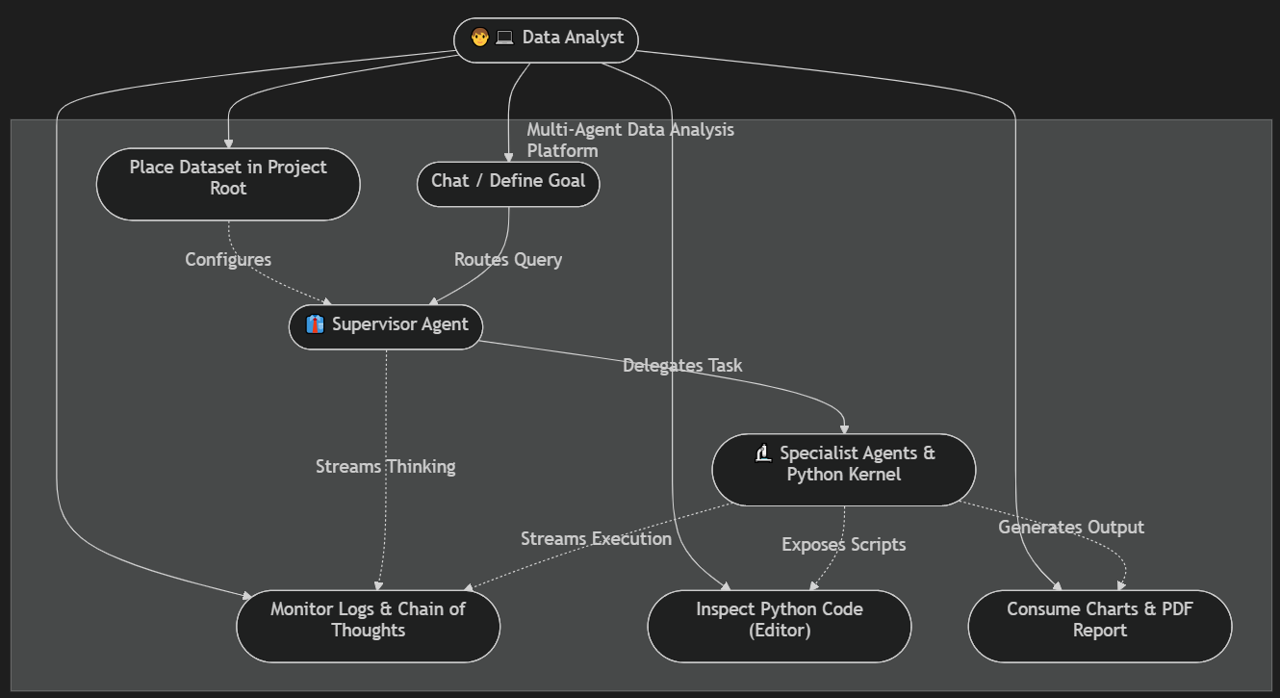
Figure 3 - Use Case Diagram (Source: author)
As the diagram displays, the user interacts with the manager agent, and the manager agent either answers the questions by using the context window or runs the specialist agents dynamically if the user requests any analysis/pre-processing operation.

Methodology
The process of conducting the research and implementing the prototype is driven based on an individual project from the candidate. Since the project specifications, requirements and deliverables were not specified and the purposed project idea was independent from the provided project list, the implementation and testing phase last until the provided submission date. The first semester covered building a prototype as a sequential pipeline with 10 AI agents without any frontend implementation. On the other hand, the second semester included redesigning the system architecture a dynamic hierarchical workflow with totally 7 agent and the frontend. The planned process is shown by the below Gantt charts:
First semester:
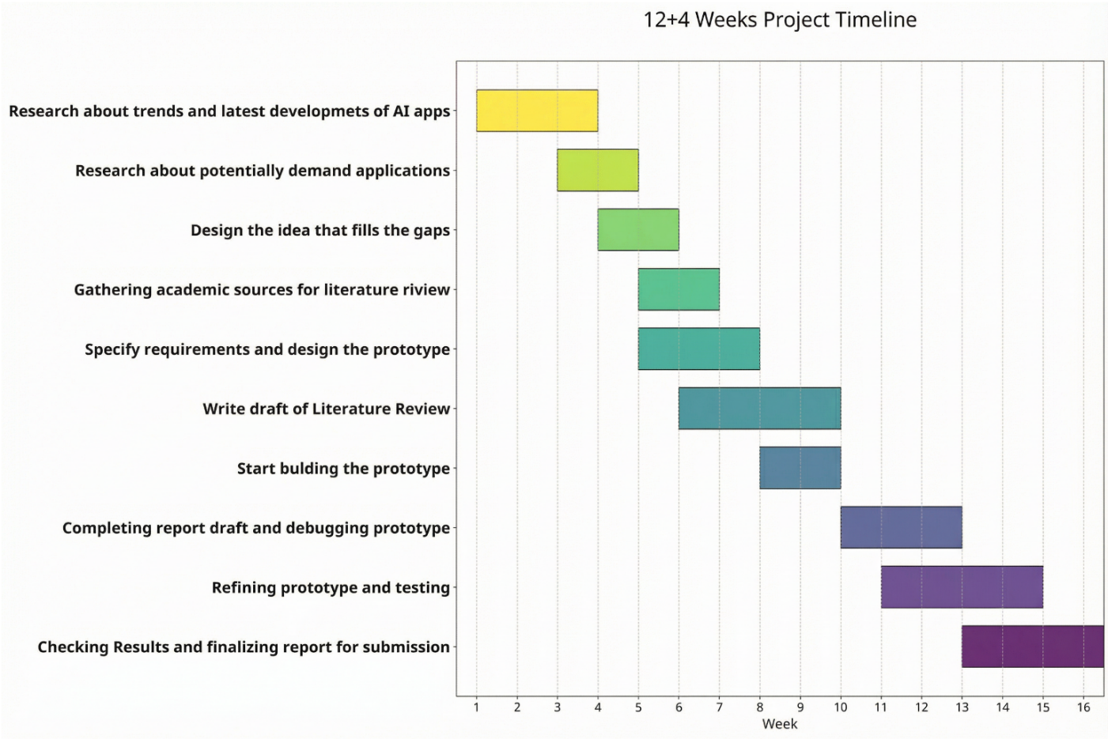
Figure 4- Gantt Chart of The Project Timeline (semester 1) (Source: author + GenAI)
Second semester
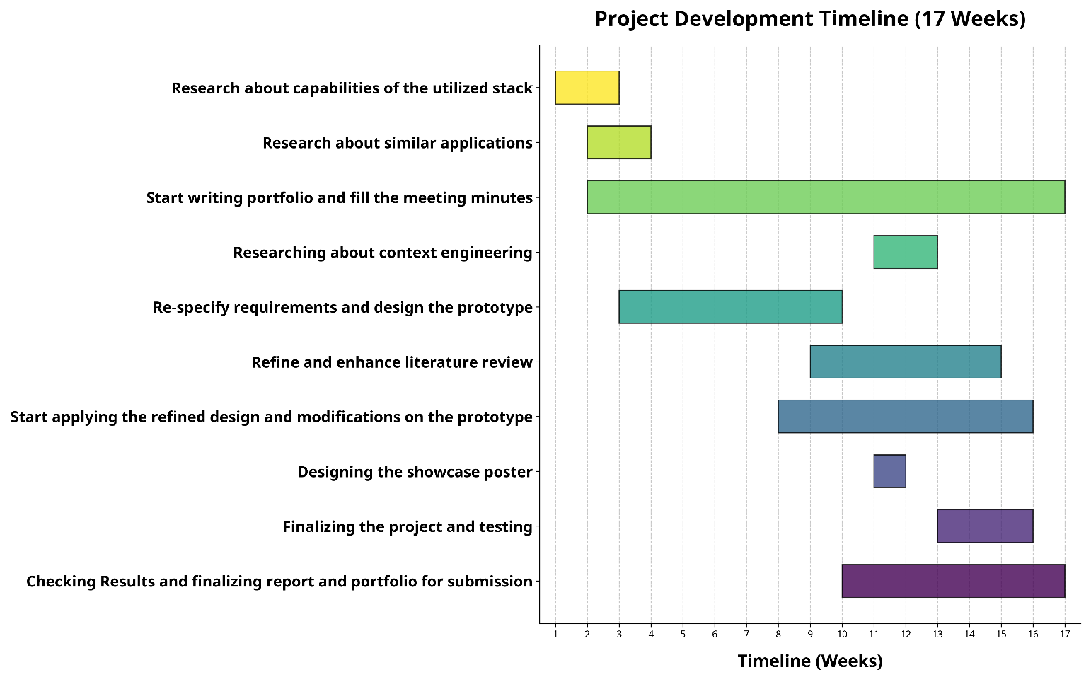
Figure 5 - Gantt Chart of the Project Timeline (semester 2) (Source: author + GenAI)
The primary focus of this report is building a working web-application with optimized observability features. The implemented project has several limitations which can be covered in further development.

Approach
Regarding the utilized technology stack, Gemini Large Language Model is selected for its robust multimodal reasoning and competitive performance in complex generative tasks (Islam and Ahmed 2024). Complementing this, the CrewAI framework was chosen to orchestrate these capabilities through its specialized role-based architecture, which effectively manages collaborative multi-agent workflows and autonomous task delegation (Joshi 2025; Hosseini and Seilani 2025).
The workflow has been implemented as a web application instead of a desktop application, so it would be usable for all type of operating systems.
The source code of the prototype is available in this GitHub repository: GitHub - Radin-Mokari/crewai-data-analysis at Final_Version · GitHub

Design, Implementation and Testing

Design

System Design
As stated before, the system creates a dynamic hierarchical multi-agent workflow to analyse CSV dataset automatically. Seven specialist agents are orchestrated by a manager (supervisor) agent at run time by producing structured JSON routing decisions. All agents share a persistence and stateful Python karnel, which is a model of “code is the universal interface” that all reasoning steps are grounded in real Python execution against the input dataset.
Since the CrewAI’s built-in Process.hierarchical follows a similar logic as a linear pipeline, a custom orchestration loop has been built to achieve the target level of dynamicity. Thus, the manager agent can observe the karnel state and the digest of all prior steps, decide the next move (delegate to one specialist, reply via chat, or end the turn), and synthesis a single and user friendly markdown answer that unites code output interpretations with the manager’s explanation.
Specialists do not talk to each other directly, but they always report back to the manager, who then re-observes and decides the next step. This produces a team-like, conversational rhythm rather than a fixed pipeline.
The application is deliberately scoped to one analysis session per server run: a single DataAnalysisWorkflow instance, one chat-lock, and one shared interpreter.
Configuration: requirements.txt pins Python dependencies for reproducibility. The .env file stores GEMINI_API_KEY, optionally AGENTOPS_API_KEY, the DATASET_PATH, the OUTPUT_DIR, plus runtime knobs.
Virtual environment: venv/ holds the isolated Python interpreter and installed packages, and ensures deployments and re-installations match the development environment. chatbot-explorer-ui/node_modules/ plays the equivalent role for the front-end's npm packages.
Backend scripts: Three core modules implement the dynamic workflow.
- crewai_data_analysis.py contains the complete pipeline: the stateful PythonSessionTool, the seven specialist Agent definitions, the manager-decision Pydantic schema and Gemini JSON call, the supervisor loop with guardrails, retry logic, persistence helpers, and report grounding rules.
- server.py exposes the FastAPI surface so the React UI and external clients can drive the same single-session workflow.
- session_state_store.py is a kernel-snapshot helper that serialises df_raw / df_clean / df_features to Parquet plus a JSON metadata sidecar, enabling resume after interruption.
- fix_bug.py patches a Windows-specific signal.SIGHUP issue inside CrewAI; smoke_deterministic_brief.py runs the deterministic dataset brief offline (no Gemini calls) for testing.
Front-end (UI): chatbot-explorer-ui/ is a Vite + React 18 + TypeScript single-page application using Tailwind and shadcn/ui. Its src/pages/Index.tsx hosts the chat shell; src/components/ holds the four harness surfaces: ChatMessage, AgentChainPanel (chain-of-thought tree), LogsSidebar (real-time workflow logs), CodeEditorPanel (Monaco editor wired to /run_code), plus the PromptIsland composer and shadcn primitives under components/ui/. src/lib/api.ts is a typed REST + SSE client; src/lib/sseParse.ts decodes the supervisor stream. Vite's vite.config.ts proxies /api/* → http://127.0.0.1:8765 so the UI uses same-origin calls in development.
Data: Any tabular dataset (CSV) is referenced by DATASET_PATH in .env. It is loaded once into df_raw at session bootstrap by PythonSessionTool.init_session(...) and is never reloaded. Every subsequent agent and the user's own code editor mutate the same in-memory frame.
Outputs: The analysis_results/ directory holds per-session artifacts. Each run creates a timestamped subfolder run_<YYYYMMDD_HHMMSS>/ containing the markdown report (analysis_report_<run_id>.md), the persisted manager conversation (manager_chat.jsonl), the per-step record (run_history.json), the deterministic dataset brief (dataset_brief.txt), the resume snapshot (kernel_snapshot/ with Parquet frames + meta.json), the rolling-summary file (conversation_summary.txt), the CrewAI verbose trace (crew_logs.json), session metadata (session_meta.json), and a charts/ subdirectory of de-duplicated PNG visualisations.
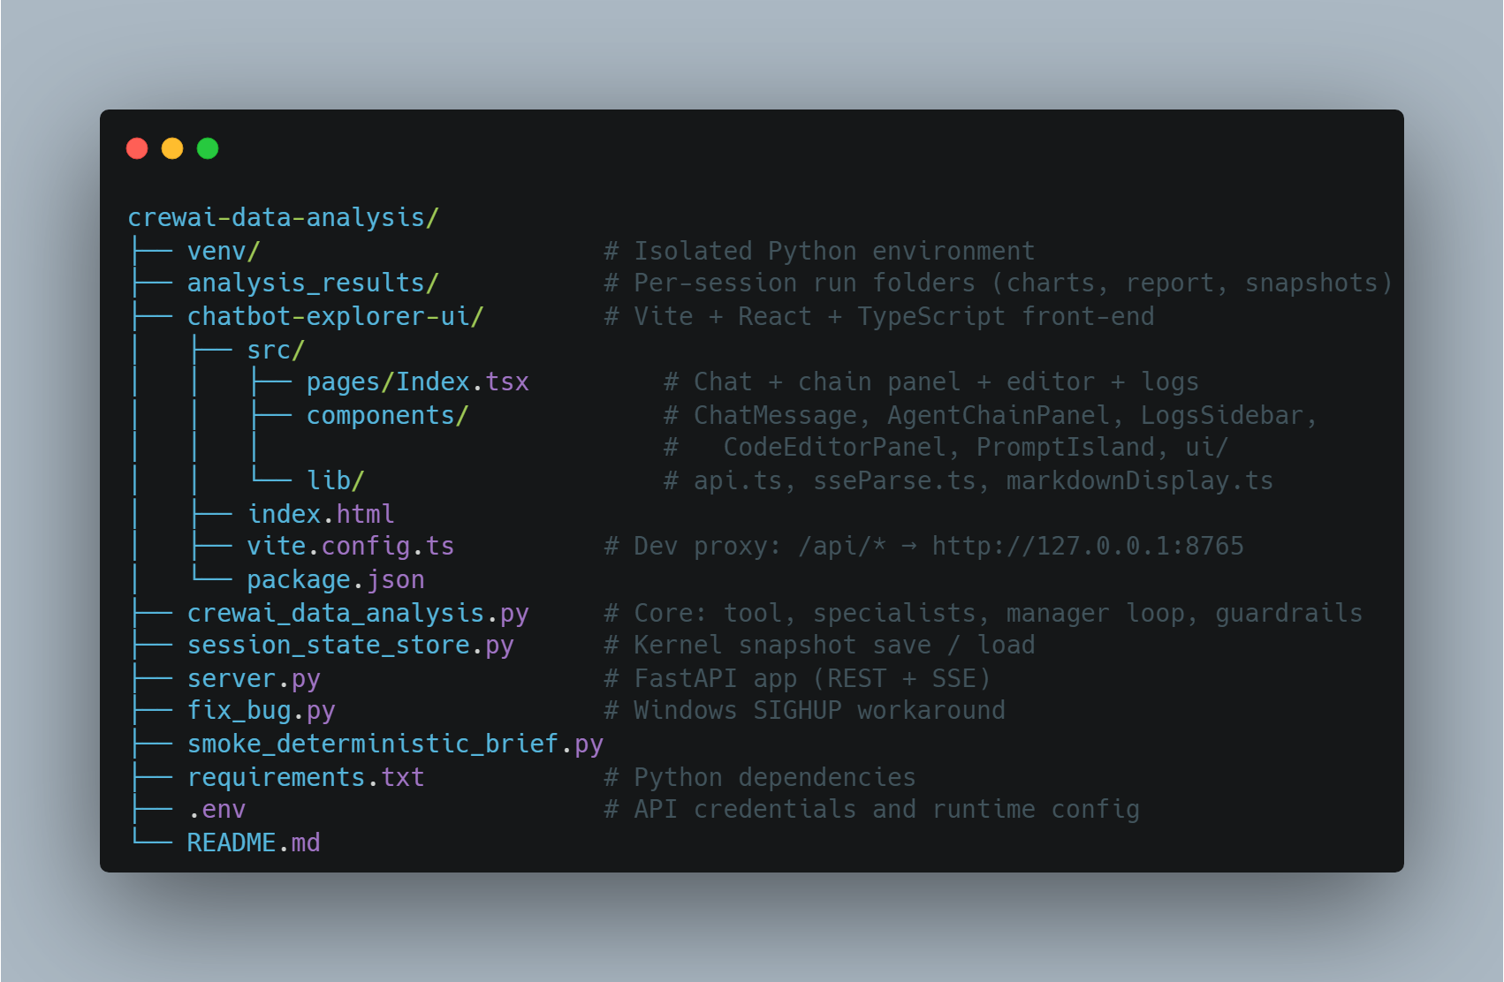
Figure 6 - Project Directory Structure (Source: author)

Hierarchical Architecture
There are two tiers in the hierarchy: A manager (supervisor) above seven specialists which all share a Python karnel, and one Run_forder persistence area.
Manager Supervisor
The manager is not a CrewAI Agent, but it is a direct call to the Gemini SDK with a constrained JSON schema (Pydantic Literal enum). This keeps routing decisions deterministic to parse, and lets the manager exist outside the Crew lifecycle, so it can survive across user turns and reuse the same kernel.
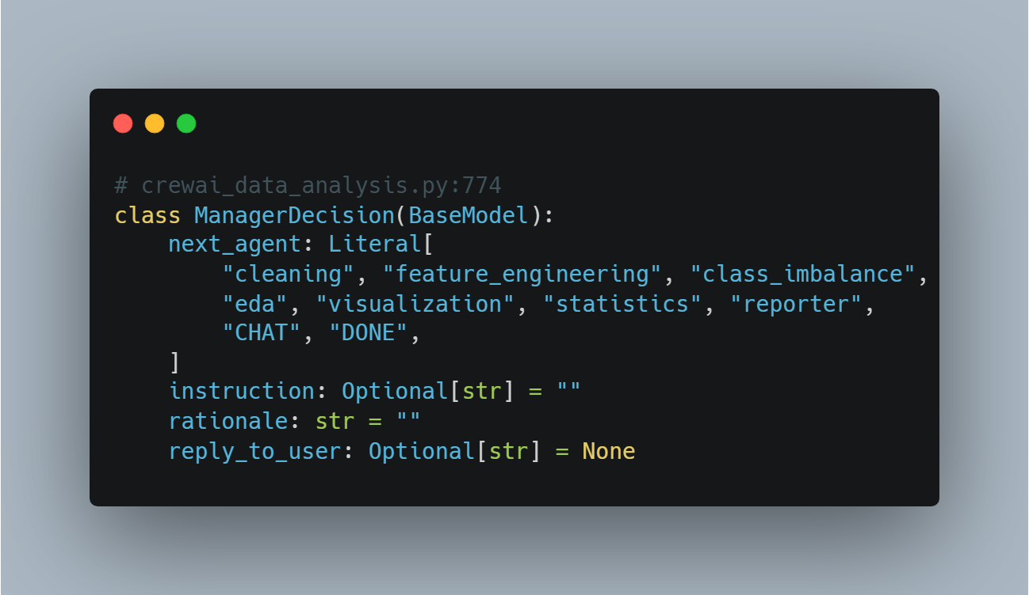
Figure 7 - Manager Decision Class (Source: author)
The nine possible outputs split into three behaviours:
Outcome | Effect
One of 7 specialist names | Build a scoped Task, run a single-agent Crew, capture excerpt + executed code
CHAT | Conversational reply with no specialist execution; user sees reply_to_user
DONE | Conclude the user's turn; optional final markdown reply
Table 3 - Output Types
Specialist Agents
Each specialist is a CrewAI Agent with allow_delegation=False, a dedicated role/backstory, the shared PythonSessionTool, and a tier-specific LLM. Specialists never call each other; the manager is the only router.
Key | Role | Reads | Writes
cleaning | Env check + profiling + validation + df_clean | df_raw | df_clean, validation_report, TIME_INDEX_OK
feature_engineering | Encoding, scaling, derived features | df_clean | df_features, refreshed NUMERIC_COLUMNS / CATEGORICAL_COLUMNS
class_imbalance | Target detection, value counts, ratios | df_clean / df_features | observations into validation_report
eda | Codified EDA: distributions, correlations | best of df_features / df_clean / df_raw | stdout (markdown tables)
visualization | Skew/cardinality-aware chart selection | df_clean (interpretable) + ORIGINAL_*_COLUMNS | PNG charts under run_*/charts/
statistics | Codified tests (Shapiro, Pearson, Kruskal …) | best df_* | stdout (test tables)
reporter | Markdown synthesis from grounded facts | session_facts_markdown() + run-history digest | analysis_report_<run_id>.md
Table 4 - Specialist Agents
Shared Resources
The shared resources across agents are the Python Karnel (PythonSessionTool) instance, which covers df_raw, df_clean, df_features, validation_report, NUMERIC_COLUMNS, CATEGORICAL_COLUNS, TIME_INDEX_OK, and pre-imported libraries, and the Run-folder persistence, that mentioned earlier.
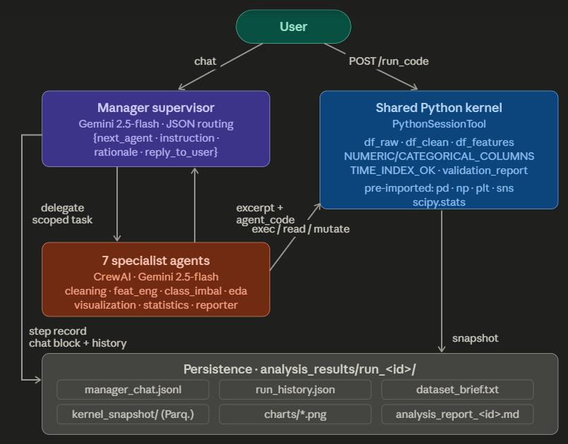
Figure 8 - Hierarchical architecture diagram (manager and the 7 specialists, shared kernel and persistence side panel (Source: GenAI)

The picture bellow shows the class diagram:
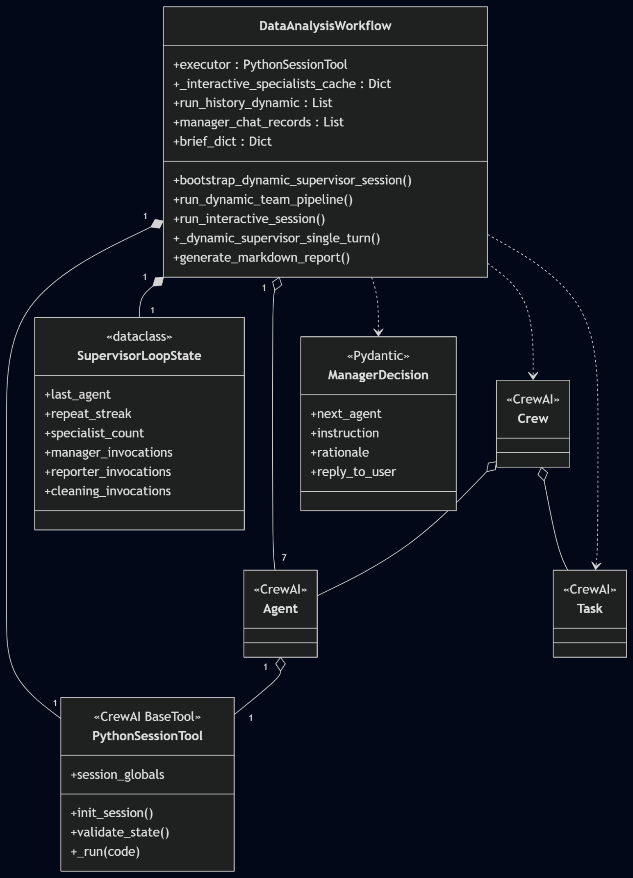
Figure 9 - Class Diagram (Source: author)
DataAnalysisWorkflow is the central class. It owns the shared kernel and the loop-state counters (filled diamond, they live and die with it), holds the seven specialist agents (open diamond, built once and reused), and uses Task, Crew, and ManagerDecision only briefly during each turn (dashed line, created and thrown away). Agent, Task, and Crew come from the CrewAI library; everything else is project code.

Harness Engineering Layers
The harness is structured as five layers, with a single focus in each and a narrow interface to the layer above and below.
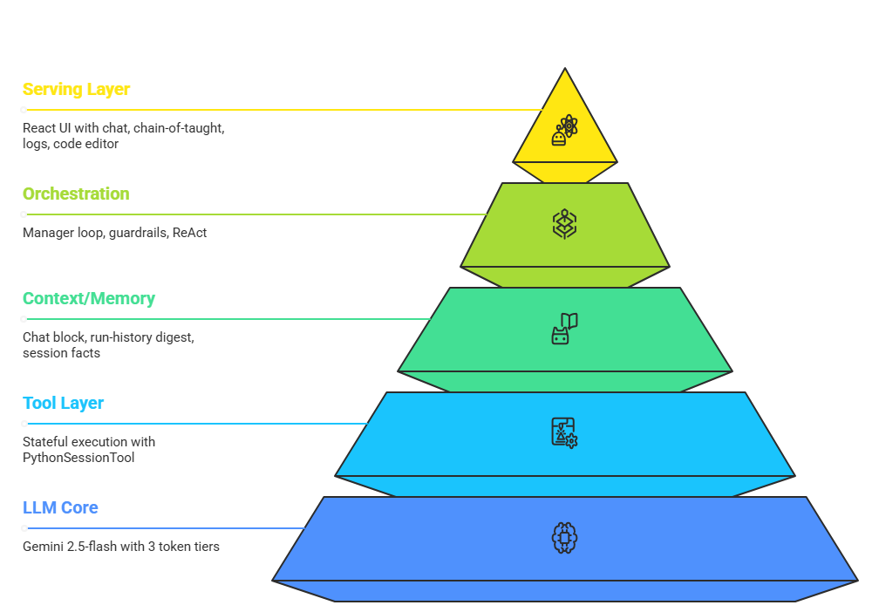
Figure 10 - Harness Engineering Layers (Source:author)
Serving Layer
The serving layer which discussed earlier, exposes four user-visible surfaces:
- Chat: Drives POST /chat/stream. The first substantive user turn locks a sessionGoals[sid] value that is reused for every subsequent /chat call as the supervisor's user_prompt.
- Chain-of-thought panel: Renders SSE events (manager_decision, specialist_start, specialist_complete, manager_message, manager_summary, guardrail) inside a collapsible "Supervisor run" tree, with a per-step “Load Code” button that injects agent_code into the editor.
- Workflow log sidebar: Shows infrastructure-only LogEvents (level × category × event × ts) on a separate channel from chain-of-thought, with level filtering and auto-scroll.
- Interactive code editor: Wraps Monaco Editor against the same kernel via POST /run_code, returning {stdout, error, charts}. Charts and df_* mutations made by the user persist into the same shared globals the agents see.
The transport is Server-Sent Events so the UI can show live chain-of-thought instead of one long opaque blocking request. The implementation pattern is a worker thread → “asyncio.Queue” bridge with a 4 KB priming burst to defeat browser/proxy buffering and a “Cache-Control: no-cache, X-Accel-Buffering: no set”:
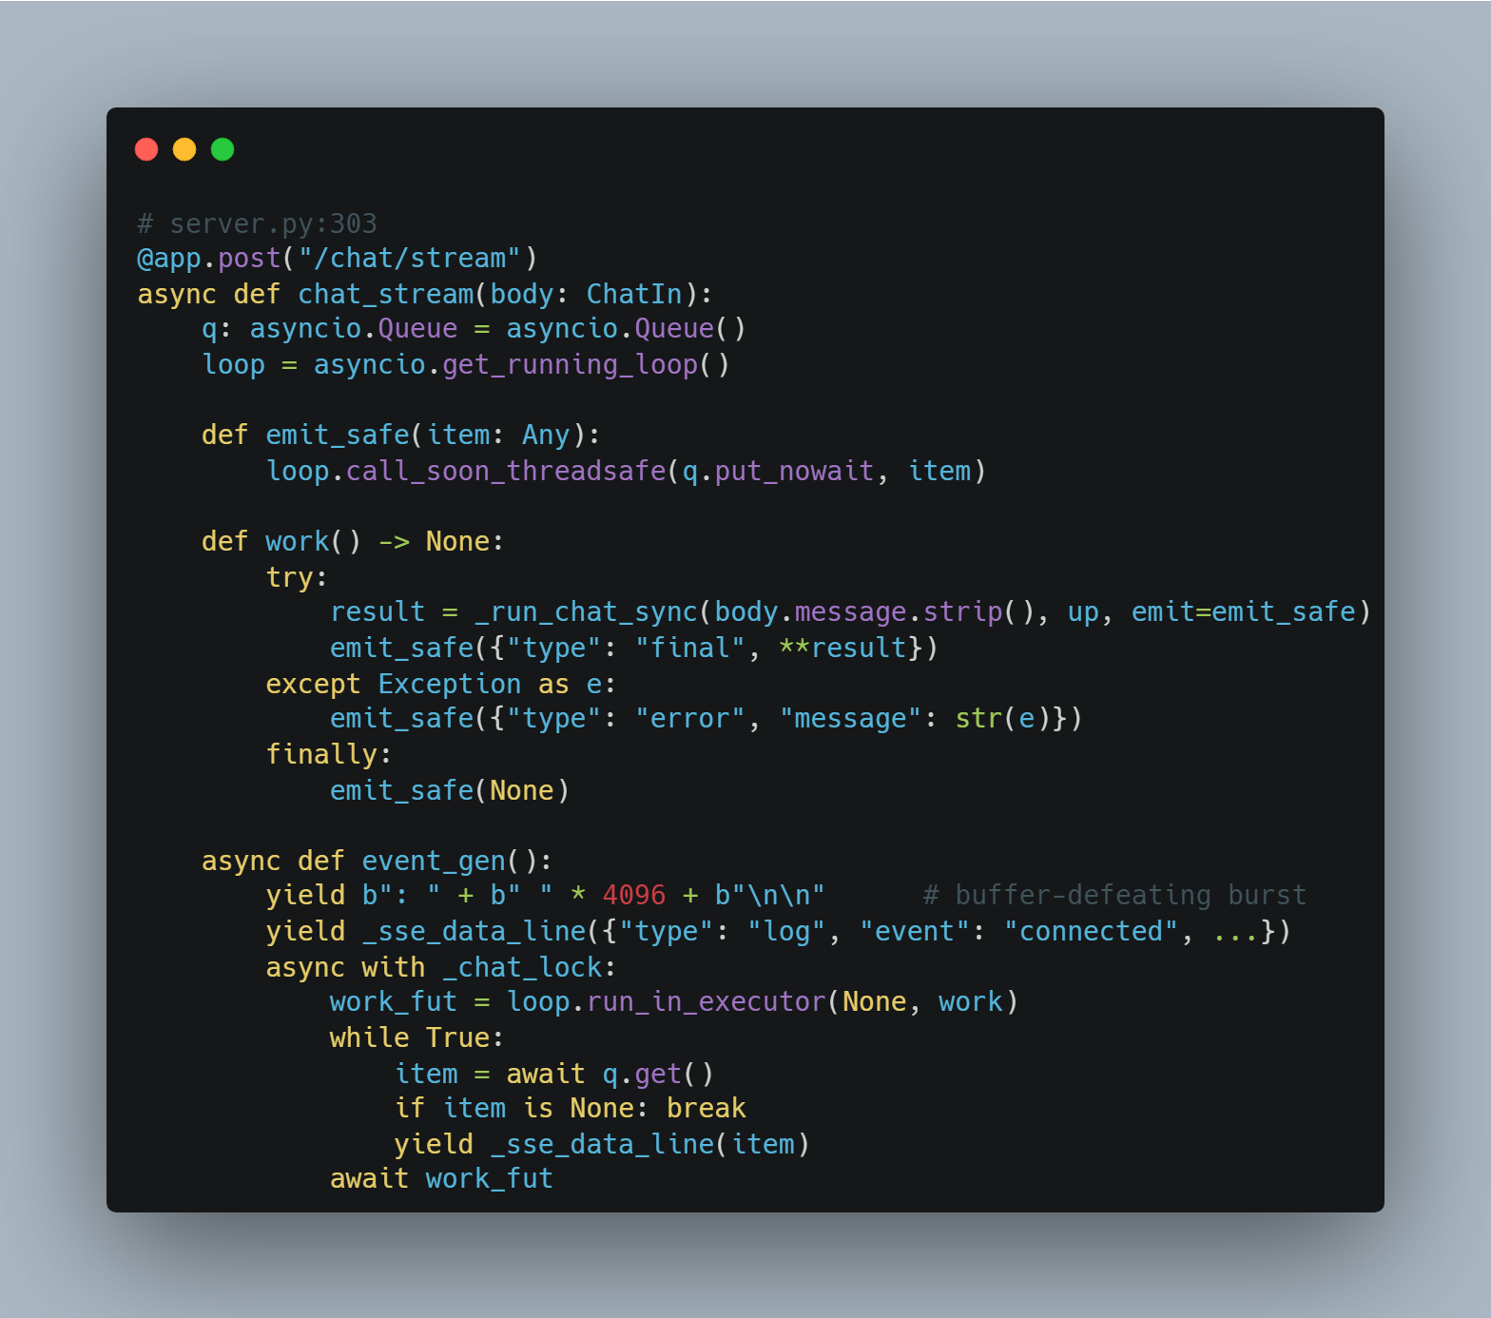
Figure 11 - Server-Sent Events (Source: author)
This returns StreamingResponse(event_gen(), media_type="text/event-stream", ...)
Orchestration Layer
The orchestration core is _dynamic_supervisor_single_turn. One call = one manager JSON decision plus at most one specialist Crew run. This works by run_interactive_supervisor_segment: one user message; loops single turns until the manager replies via CHAT or DONE (web chat / stdin).
Context Engineering & Memory Layer
The system uses a layered memory pattern instead of CrewAI's built-in vector memory. Built-in vector memory is a general solution to the wrong problem here: the routing decisions and the report depend on kernel state and exact numbers, not on semantic similarity over past LLM text. A layered memory: kernel-grounded facts + structured run-history digest + sliding-window chat with rolling summary, gives stronger grounding, deterministic context selection, and lower token cost for the bounded sessions this MVP targets, at the cost of more engineering than memory=True would have required.
Memory tier | Source | Role in the prompt
Working state (kernel) | validate_state() flags + session_globals | Ground-truth booleans (has_df_clean, time_index_ok) injected into the manager payload
Episodic (run_history.json) | every specialist step | format_run_history_digest(...) - last N steps, each capped per char budgets
Conversational (manager_chat.jsonl) | every manager turn | build_manager_chat_block_for_llm(...) - sliding window with rolling summary when over budget
Long-term snapshot | kernel_snapshot/ Parquet + meta | try_load_kernel_snapshot() on resume
Deterministic facts | compute_dataset_brief() + session_facts_markdown() | Reporter grounding so the LLM cannot fabricate numbers
Table 5 - Context Engineering and Memory Layer
When the chat block exceeds MANAGER_CHAT_BUDGET_CHARS (default 28 000), the head is summarised by Gemini and persisted as conversation_summary.txt; the tail keeps MANAGER_CHAT_KEEP_RECENT records (default 14):
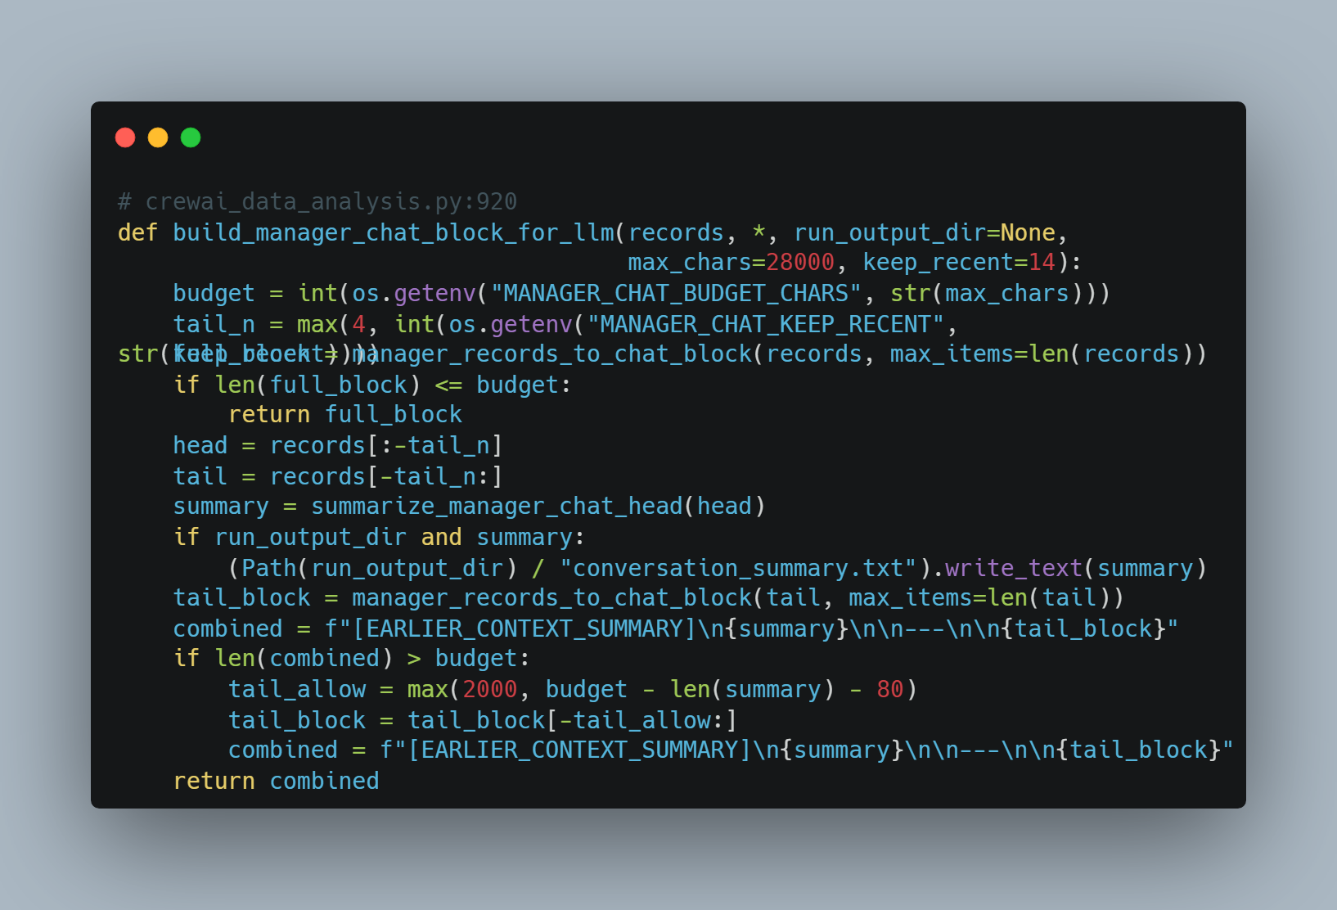
Figure 12 - Manager Chat (Source: author)
This is a hybrid sliding-window + rolling-summary strategy. The supervisor never sees an unbounded prompt but never loses long-range context either.
Tool Layer
A PythonSessionTool is the only tool the specialists have. It is a CrewAI BaseTool wrapping an in-process Python exec against a persistent globals dict. Charts are captured by intercepting plt.savefig (forced into the run-folder) and by walking plt.get_fignums() after execution, deduplicating images by MD5 before writing to disk:
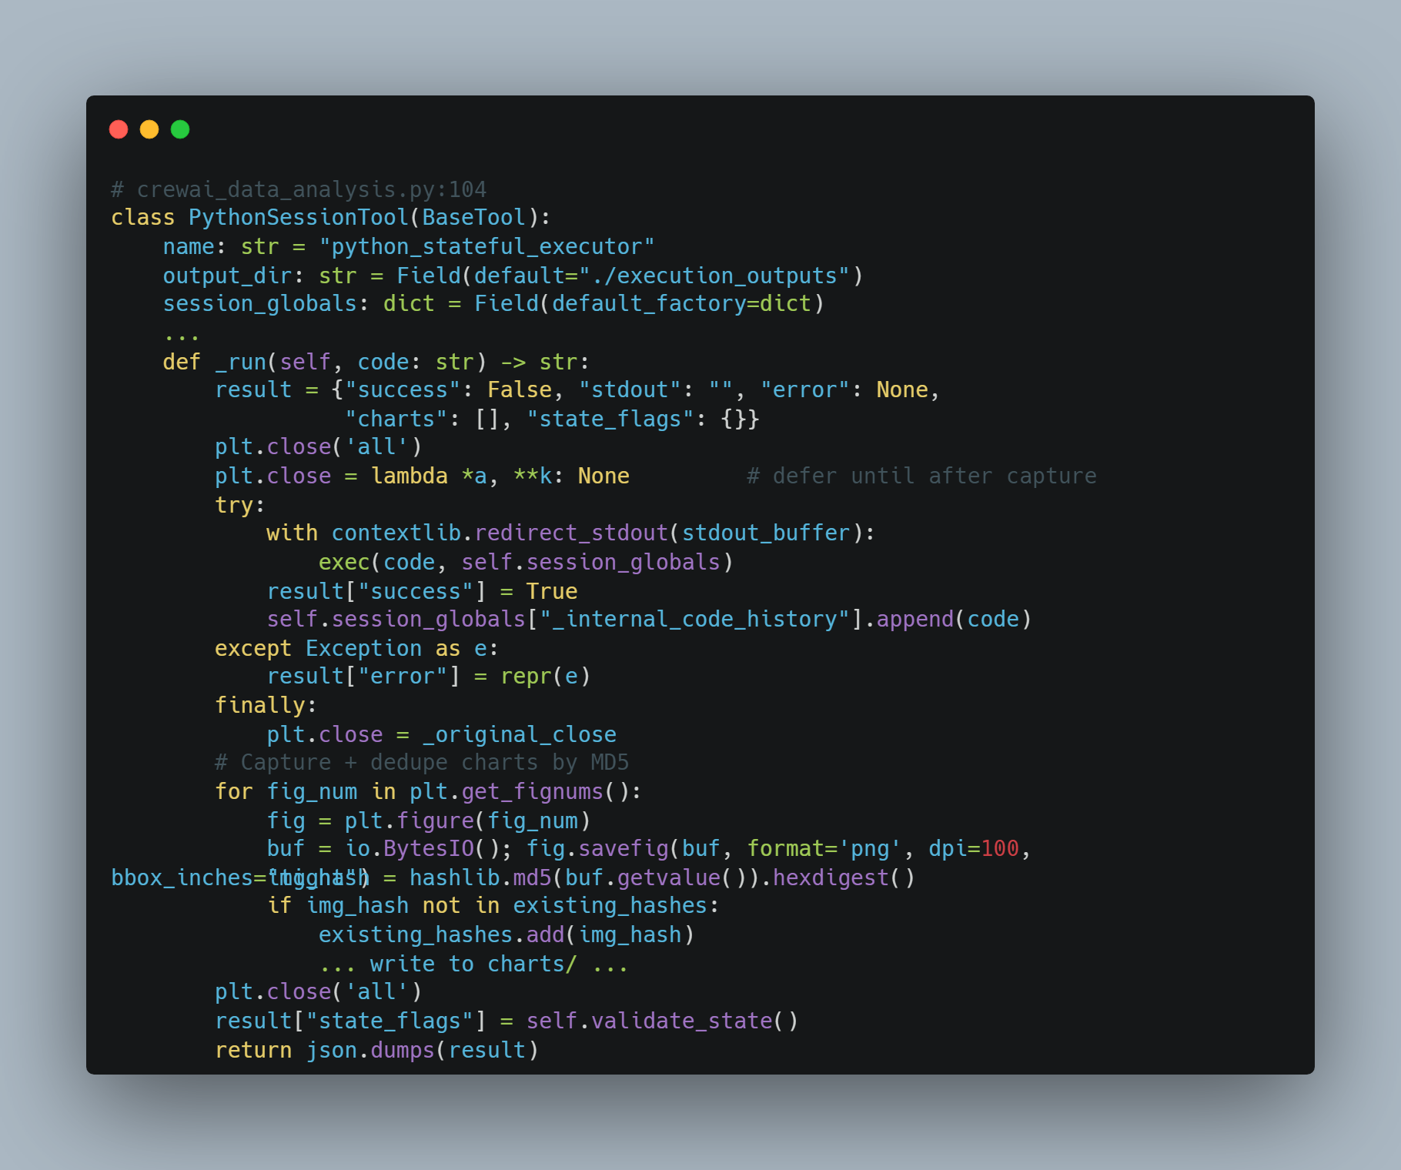
Figure 13 - PythonSessionTool Class (Source: Author)
Two side-effects of this design are worth noting:
- The same kernel is exposed unmodified to the UI's code editor via POST /run_code; the user can poke at df_clean immediately after a specialist produces it.
- _internal_code_history accumulates each agent's executed code; after each specialist finishes, this is attached to the specialist_complete SSE event as agent_code, so the UI's "Load Code" button can replay it in the editor.
LLM Core Layer
All LLM calls go to Gemini 2.5-flash. Token budgets are stratified into three tiers so simple tasks do not pay long-context cost:
Tier | max_output_tokens | Used by
llm_medium | 2048 | cleaning, feature_engineering, class_imbalance, eda, visualization, statistics
llm_long | 4096 | reporter (synthesises a full markdown report)
Manager | unset / JSON only | direct genai.GenerativeModel("gemini-2.5-flash", system_instruction=..., generation_config={"response_mime_type": "application/json"}) google
Table 6 - LLM token Stratification
The manager call is configured with response_mime_type="application/json" so Gemini is forced to emit a JSON-shaped reply, which the reason routing parse failures are extremely rare.
Additionally, token usage is measured, not just budgeted. Each manager and specialist call is tokenised with “tiktoken” and the count is attached as the tokens field on the corresponding LogEvent. The Logs sidebar then displays per-step usage in real time, allowing the budget tiers to be validated empirically and providing the signal needed to tune MANAGER_CHAT_BUDGET_CHARS, SUPERVISOR_DIGEST_EXCERPT_CHARS, and the per-specialist max_output_tokens against actual workloads rather than guessed limits.

Session Architecture
A "session" is the lifetime of one DataAnalysisWorkflow instance, identified by a timestamped run_id (YYYYMMDD_HHMMSS). The session model is intentionally minimal; one user, one workflow, one kernel, that are protected by a single global asyncio.Lock:
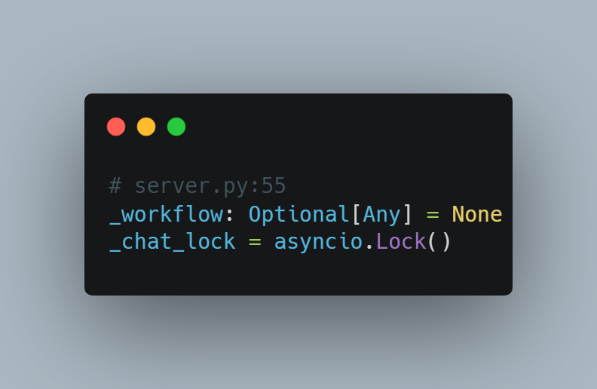
Figure 14 - Global asyncio.Lock (Source: author)
Every long-running endpoint (/chat, /chat/stream, /pipeline, /pipeline/stream, /report, /reset, /run_code) acquires this lock for its full duration; the /pipeline/stream endpoint specifically holds the lock around the entire SSE generator, not just the handler entry, so a chat call cannot interleave with a batch run.
Session bootstrap (bootstrap_dynamic_supervisor_session) is idempotent, that computes the deterministic dataset brief once, writes session_meta.json, optionally seeds the initial chat, and constructs the specialist agents. So subsequent calls only append follow-up messages.

Execution Layer
The execution layer turns a manager decision into an actual specialist Crew run. Each specialist execution follows a strict 6-step contract:
- Pre-flight state probe: executor.validate_state() returns booleans (has_df_raw, has_df_clean, has_df_features, time_index_ok) injected into the manager payload.
- Build payload: chat_block (memory layer) + run_history_digest + user_goal + validate_state JSON.
- Manager decision: JSON-only Gemini call with retries.
- Guardrail post-processing: five rule rewrites that may override the manager's choice.
- Specialist Crew run: single-agent Crew(process=Process.sequential) with the chosen specialist + dynamically built Task.
- Post-flight state capture: flags re-read, excerpt + executed code stored, snapshot saved, step_delay sleep.

State Validation
State validation exists at three points in the loop:
- Inside the kernel: validate_core_state() injected at session init verifies required globals before each agent's code runs.
- Per call from the executor: PythonSessionTool.validate_state() returns the boolean state flags consumed by the manager prompt.
- In the orchestrator: Six hard guardrails rewrite the manager's decision when it would be unsafe. These act as safety rails between the LLM's intent and the actual specialist invocation:
Guardrail | Trigger | Rewrite
df_clean_required | Any specialist other than cleaning/CHAT/DONE chosen while df_clean is None | Force cleaning (up to MAX_CLEANING_INVOCATIONS_PER_SEGMENT, default 2)
time_index_required | Time-series + feature_engineering chosen + TIME_INDEX_OK == False | Force cleaning to sort chronologically
reporter_cap | reporter chosen and reporter_invocations >= MAX_REPORTER_INVOCATIONS_PER_SEGMENT (1) | Convert to CHAT with a "report already exists" reply
cleaning_cap | cleaning chosen but df_clean exists and cleaning_invocations >= MAX_CLEANING_INVOCATIONS_PER_SEGMENT | Redirect to eda
same_agent_repeat | Same next_agent chosen ≥ SAME_AGENT_REPEAT_MAX (default 2) consecutive times | Stop the turn (exit_repeat)
manager_turn_cap | manager_invocations > INTERACTIVE_MAX_MANAGER_TURNS | Stop (exit_manager_cap)
specialist_step_cap | specialist_count >= DYNAMIC_MAX_STEPS (default 18) | Stop (exit_specialist_cap)
Table 7 - Guardrails
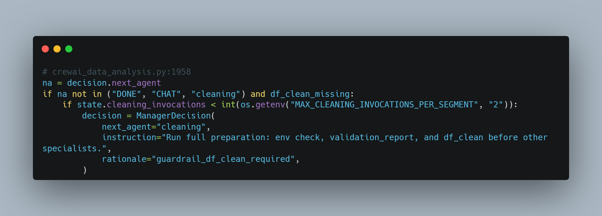
Figure 15 - Hallucinate-free Decision Making (Source: author)
The contract is that the LLM proposes; the orchestrator disposes, that keeps the system robust against hallucinated decisions.

Prompt Strategies
Five prompt-engineering strategies are layered to keep token use low and answers grounded.
CORE MODE
Every specialist backstory begins with DYNAMIC_CORE_MODE, which contain explicit rules that the libraries (pd, np, plt, sns, matplotlib, Path) and DataFrames (df_raw, df_clean, df_features) are pre-loaded; no read_csv, no re-imports, use DATASET_COLUMNS / NUMERIC_COLUMNS / CATEGORICAL_COLUMNS instead of hard-coding names.
Codified Prompting
The eda and statistics specialists must emit a pseudocode plan first, then execute. Example from build_specialist_task:
CODIFIED EDA: plan then execute on best df_*.
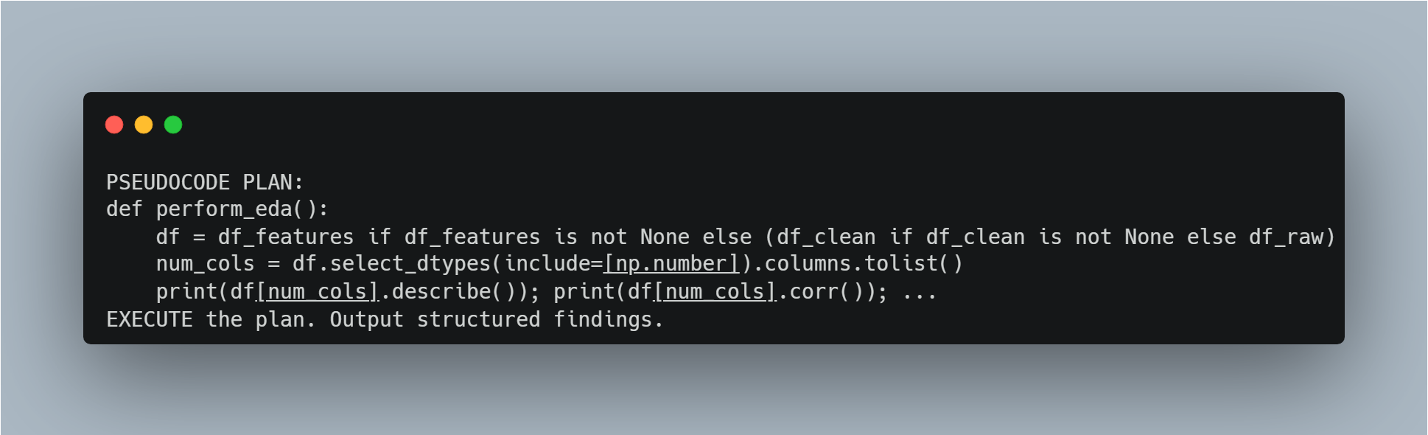
Figure 16 - Codifies Plan (Source: author)
This forces a separation between intent and execution and produces noticeably more structured outputs.
Inspector Mode (one-shot self-repair)
Each specialist backstory carries: "If your code raises an error, fix the specific issue and try once more. Do NOT re-run code that already succeeded." And combined with CrewAI's max_iter=4–8, max_retry_limit=1 per agent, this gives the agent a single self-repair attempt before kicking back up to the orchestrator's retry layer.
Reporter Grounding
The reporter prompt is hardened against fabrication via REPORTER_GROUNDING_RULES and injection of two deterministic blocks:
- SESSION FACTS, that are built from the live kernel by _session_facts_markdown() (real df.shape, real column lists, real validation_report).
- COMPLETED ANALYSIS STEPS, which are recorded by format_run_history_digest(...) with extra-large excerpt budgets (6 000 chars).
A post-hoc check _report_text_has_placeholders rejects any output containing bracket markers like [Number], [Percentage], etc., and falls back to a regenerated pass.
Synthesised Reply (the "ChatGPT-style" answer)
After a turn, if specialists ran but the manager's reply_to_user is short (< 800 chars), the server calls generate_turn_summary, a Gemini pass that fuses all specialist excerpts into a single unified answer with prescribed structure (Brief intro → Data & results in tables → Findings → Recommendations) and explicit anti-patterns ("do NOT include ![alt](path) image links, file paths, raw JSON, or Thought: / Action: agent noise").

ReAct Loop
The dynamic workflow implements a closed-loop Observe → Think → Execute → Quality-Gate cycle around the manager. Each iteration of the loop is one call to _dynamic_supervisor_single_turn.
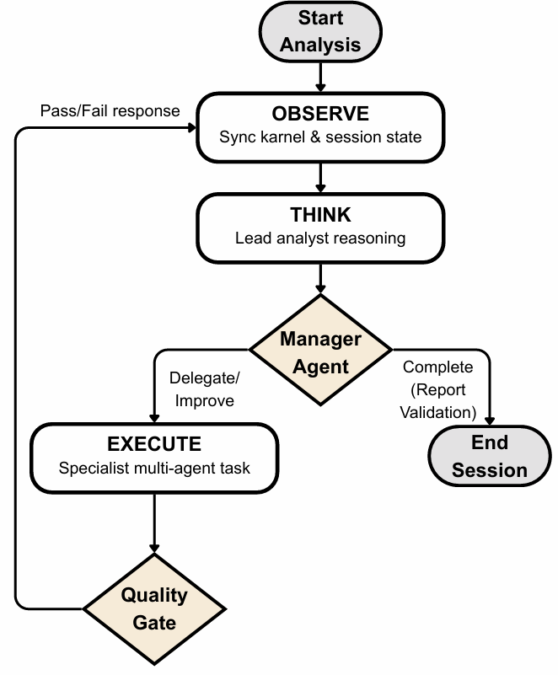
Figure 17 - REAct Loop Diagram (Source: author)
The loop is truly closed: every specialist outcome becomes part of the next prompt's context (via analysis_digest records appended to manager_chat.jsonl and the run_history.json digest), so the manager's next "Think" stage is informed by every prior "Execute".

Retry, Error Detection & Rate Limiting
Manager-decision retries
The JSON parser wraps three attempts with a sanitisation pass (Gemini occasionally generates invalid backslash escapes inside markdown content embedded in JSON):
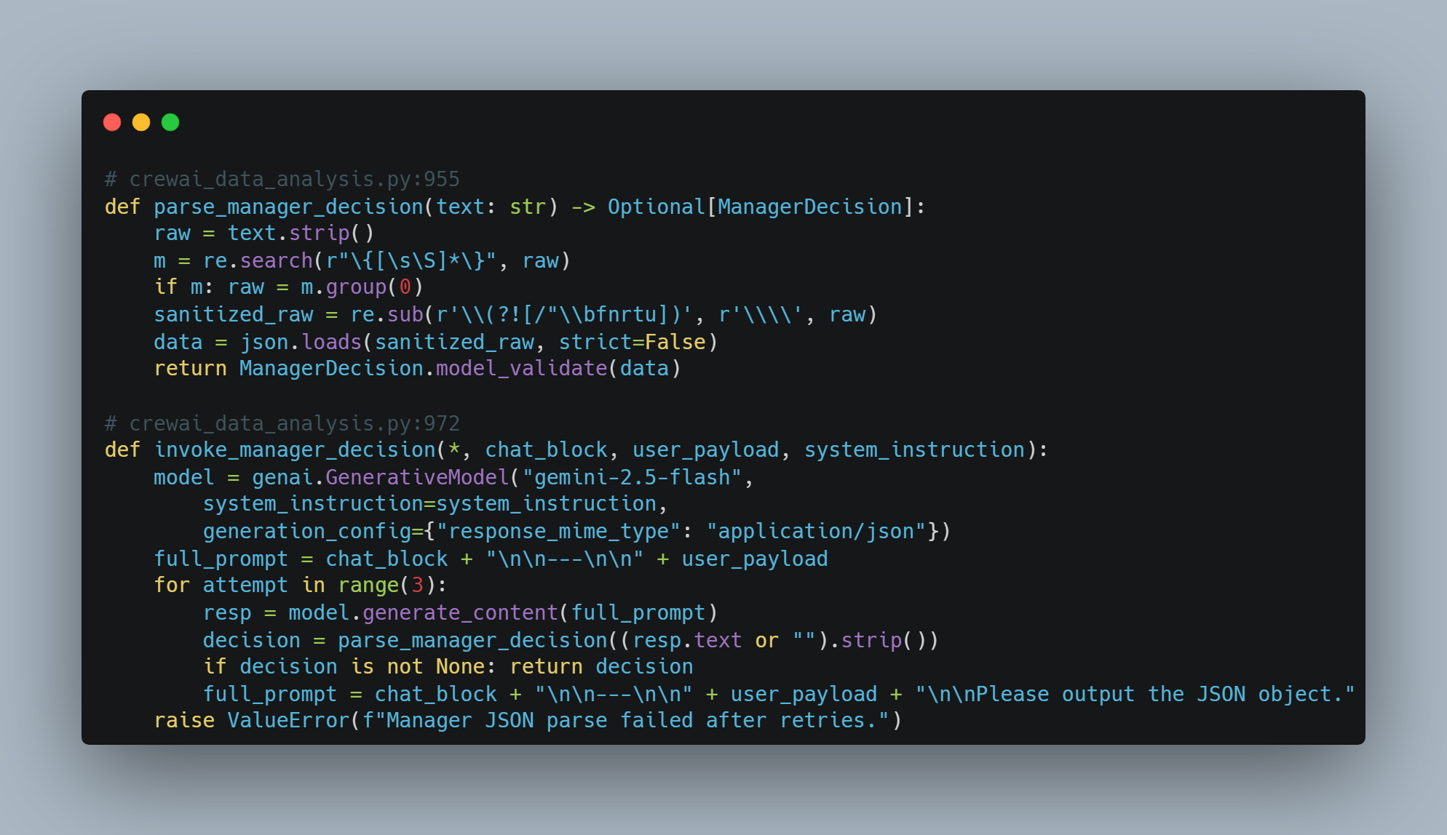
Figure 18 - Manager Retry (Source: author)
Specialist-Crew retries with back-off
_run_task_with_retry wraps each specialist Crew call in max_retries=2 (so up to 3 total attempts) with delay_seconds=4 between attempts. Failures are caught broadly, logged through the SSE log channel (category: "task", event: "attempt_failed" / "retry" / "retry_exhausted"), and persisted into self.results[task_key] either as a successful string or "Error after retries: <repr>":
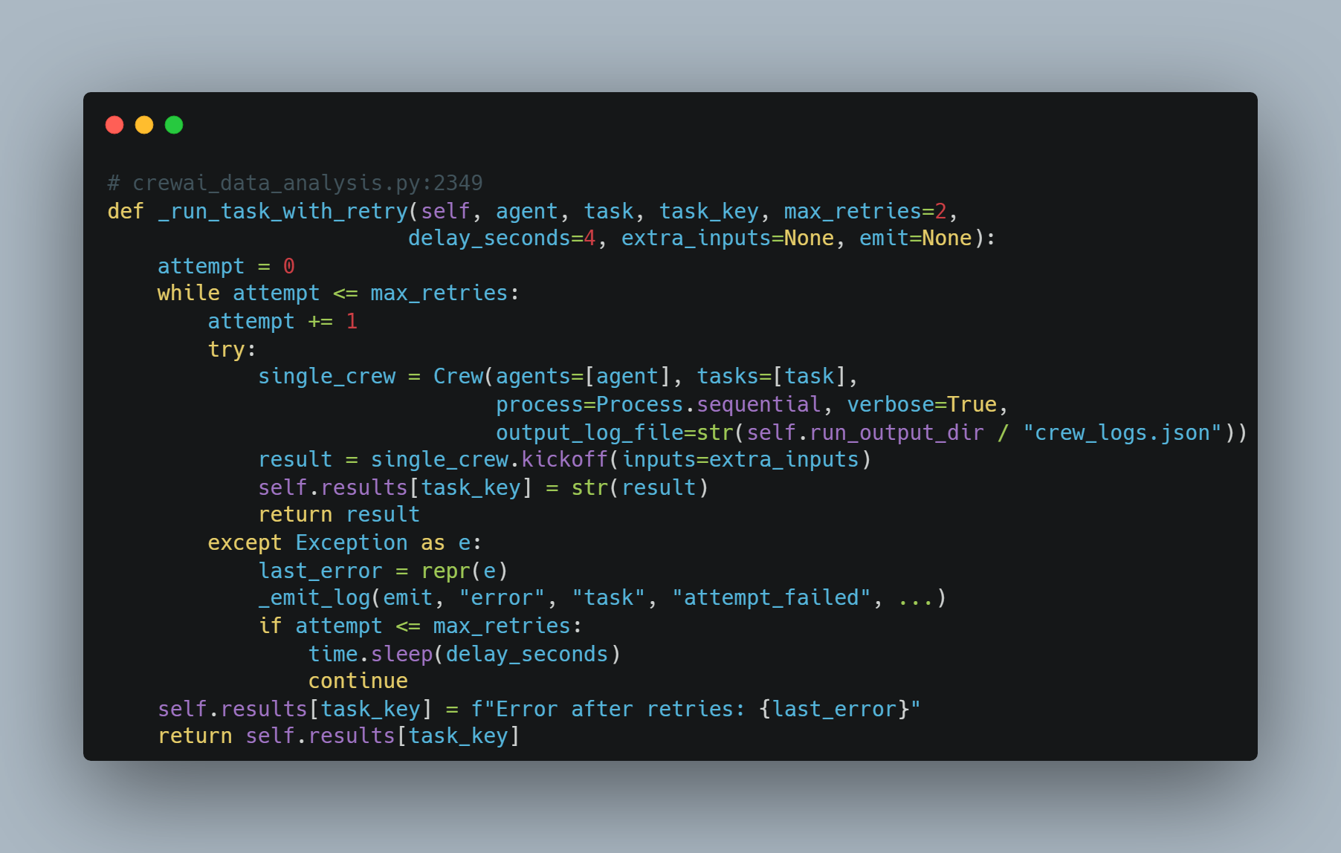
Figure 19 - Agent Retry (Source: author)
Rate Limiting
Between every supervisor turn the loop sleeps by DYNAMIC_STEP_DELAY_SECONDS (default 2 s) in both after a CHAT reply and after a specialist run. This is a soft rate-limit: it caps burst load on the Gemini API rather than reacting to a 429 after the fact. Combined with the per-task retry back-off (4 s × 2), the system never hammers the API faster than ~1 manager call per ~3 s under normal operation.
The agent's tool-side max_iter (4-8) and max_retry_limit=1 (set on every CrewAI Agent) acts as a third bound, which prevents a runaway agent from issuing dozens of tool calls in a single Crew run.
Error Detection
Errors are caught and surfaced at four distinct points so a failure at any layer is observable:
Layer | Detection | User-visible signal
Tool layer | try/except Exception around exec(code, ...) in PythonSessionTool.run; sets result["error"], emits tool/error log | Specialist sees traceback in next iteration → Inspector Mode
Specialist Crew | try/except around single_crew.kickoff() → 3-attempt back-off | task/attempt_failed log → final task/retry_exhausted if all fail
Manager LLM | try/except around invoke_manager_decision; emits manager/decision_failed | Streamed up; turn aborts
Orchestrator | Outcome enum: exit_manager_cap, exit_specialist_cap, exit_repeat | guardrail SSE event + sidebar log
Table 8 - Error Detection Layers (Source: author)

Persistence & Artifacts
Every state-changing operation writes to disk synchronously inside the run folder.
Artifact | Writer | When
manager_chat.jsonl | append_manager_chat_record() | After every manager turn (fsync’d)
run_history.json | save_dynamic_run_history() | After every specialist
dataset_brief.txt | compute_dataset_brief() | Once at session bootstrap
kernel_snapshot/ | save_kernel_snapshot() | After every specialist (toggle: SESSION_SNAPSHOT)
charts/.png | PythonSessionTool.run | After every kernel exec (deduped by MD5)
analysis_report_<run_id>.md | save_report_to_file() | On /report, on session exit, or after batch run
conversation_summary.txt | build_manager_chat_block_for_llm() | When chat block exceeds budget
crew_logs.json | CrewAI output_log_file... | Per task
session_meta.json | bootstrap_dynamic_supervisor_session() | Once at bootstrap
Table 9 - Persistence & Artifacts

Implementation
The implementation of the prototype involves eight foundational components, including front-end that provide stateful and fault-tolerant data analysis through coordinated multi-agent execution.

Stateful Tool – PythonSessionTool
The tool is the foundation of the whole system. Initialisation injects the dataset and the Core-Mode global:
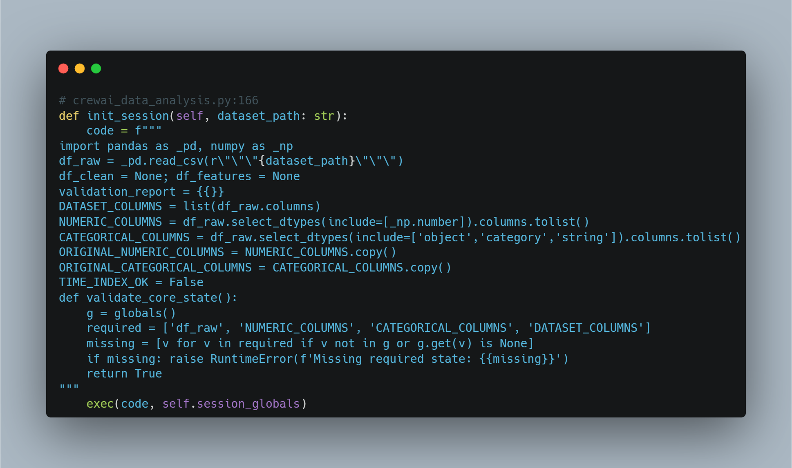
Figure 20 - Session Initialisation Function (Source: author)

Specialist Construction
Specialists are created in create_dynamic_specialist_agents. Here is an example for the EDA agent:
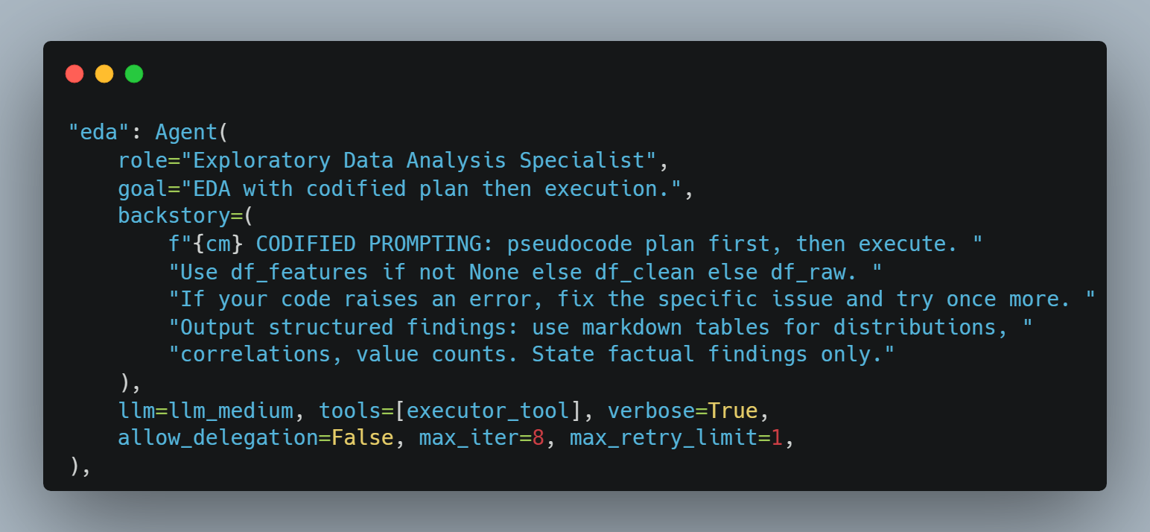
Figure 21 - Example Specialist Agent from EDA Agent (Source: author)

Manager Decision Call
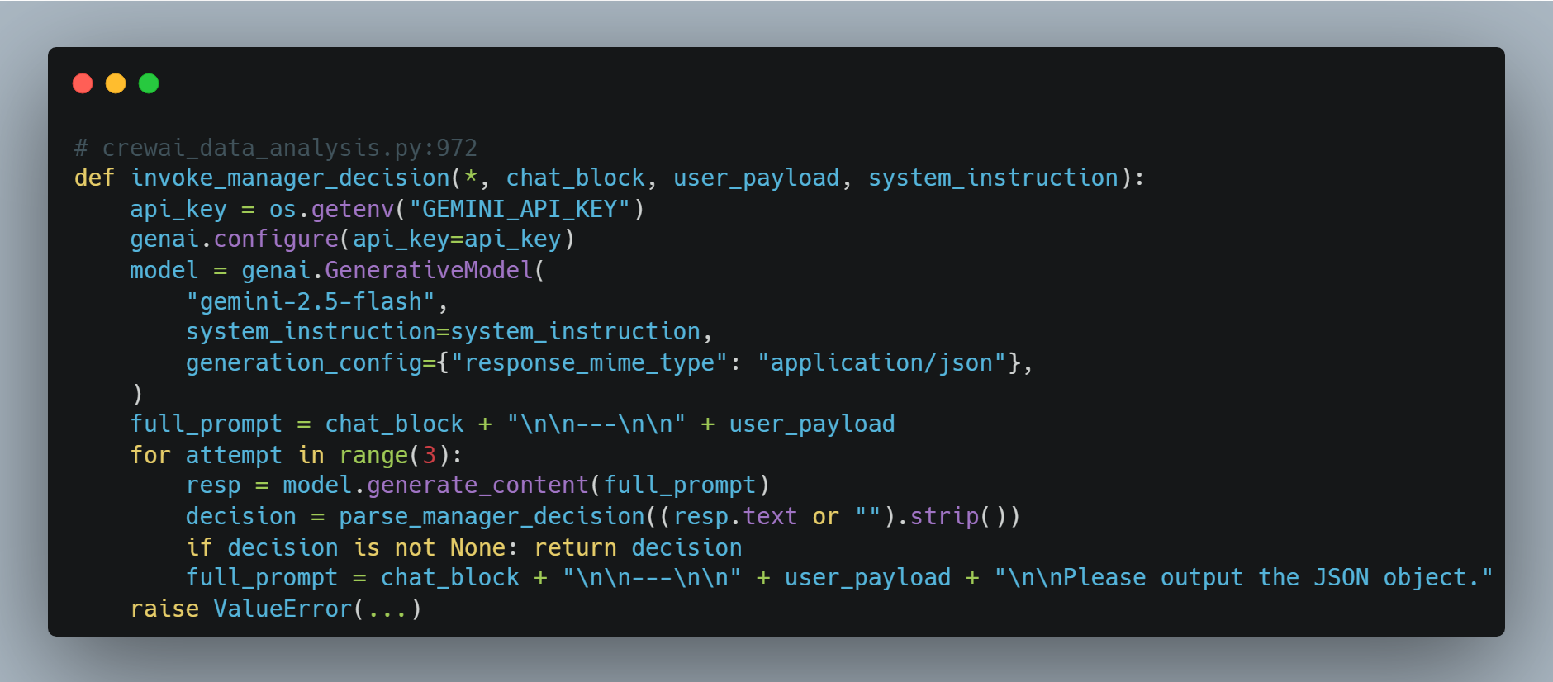
Figure 22 - Manager Decision Call Function (Source: author

Orchestrator Single Turn
The full body of _dynamic_supervisor_single_turn (crewai_data_analysis.py:1861-2183) implements the entire ReAct loop iteration in one function: observe → think → guardrail-rewrite → execute → record. The annotated flow is:
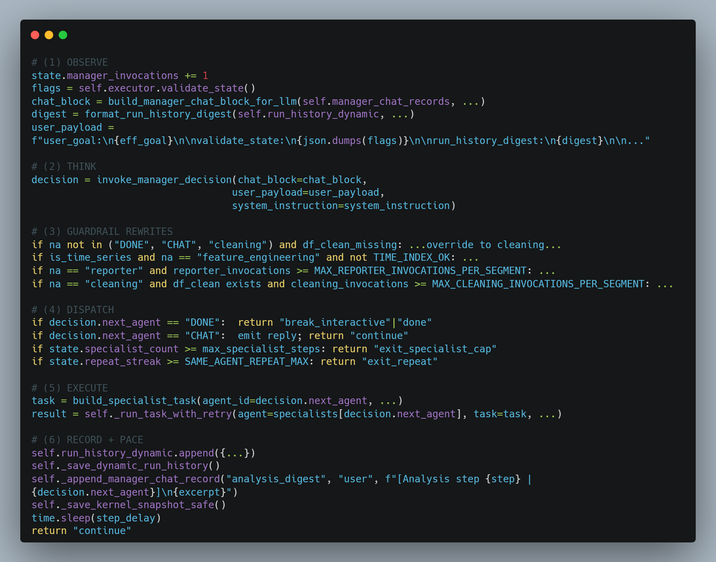
Figure 23 - ReAct Loop Iteration (Source: author)

SSE Streaming & Log Channel
The are two distinct channels that travel over the same SSE stream:
Chain-of-thought events
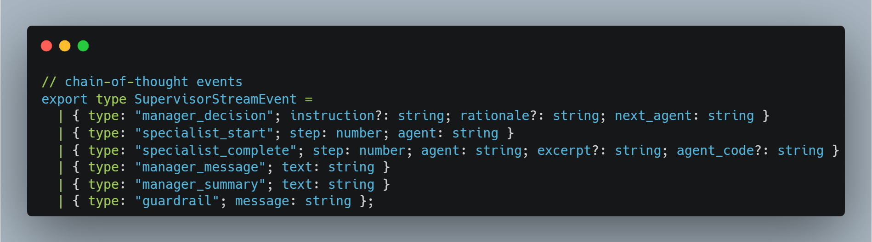
Figure 24 - Chain-of-thought Channel in SSE Stream (Source: author)
Infrastructure log events
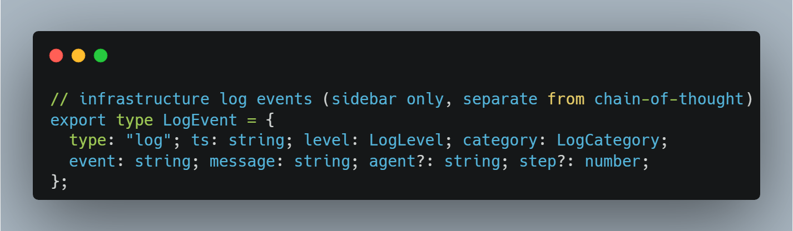
Figure 25 - Infrastructure Log Channel in SSE Stream (Source: author)

Karnel Snapshots
Snapshots write df_raw / df_clean / df_features as Parquet plus a meta.json with the metadata lists and validation report:
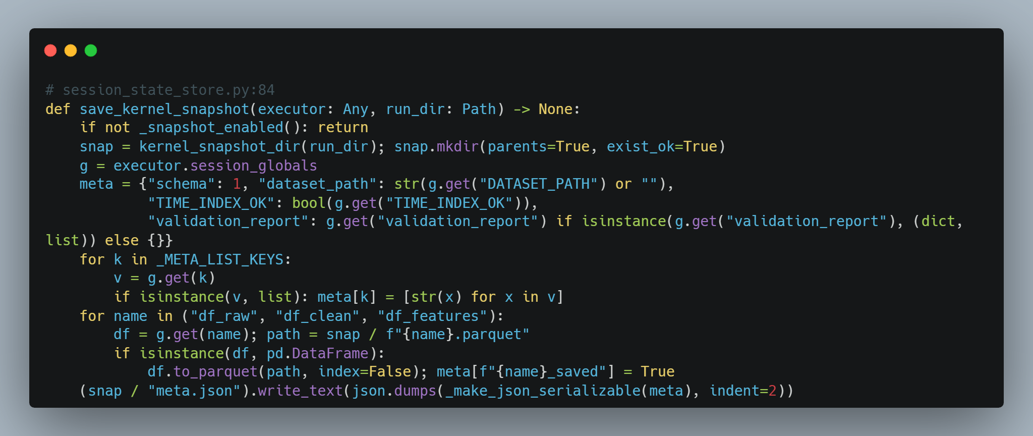
Figure 26 - Karnel Snapshots Function (Source: author)

FastAPI Surface
Four React components carry most of the harness UX:
Chat (Index.tsx, ChatMessage.tsx, PromptIsland.tsx): Index.tsx hosts the shell, accumulates SSE events into chainAccRef, locks the session goal on the first substantive turn, and dispatches /chat/stream, /pipeline/stream, and /report. ChatMessage.tsx renders user / bot bubbles with the collapsible "Supervisor run" tree embedded inside each bot reply. PromptIsland.tsx is the composer textarea, specialist action chips (Cleaning, EDA, Visualization, Statistics, Feature Engineering, Class Imbalance, Reporter), and send button.
AgentChainPanel.tsx: Collapsible "Supervisor run" tree of manager_decision / specialist_* / guardrail events with a per-step Load Code button that injects agent_code into the editor.
LogsSidebar.tsx: Left rail with level filtering (info / warn / error) and category icons (workflow, manager, specialist, task, tool, guardrail).
CodeEditorPanel.tsx: Monaco editor wired to POST /run_code, showing stdout, error, and inline <img> for any charts produced.

Testing

UI Screenshots
The pictures bellow demonstrates the UI of the project after several manual testing:
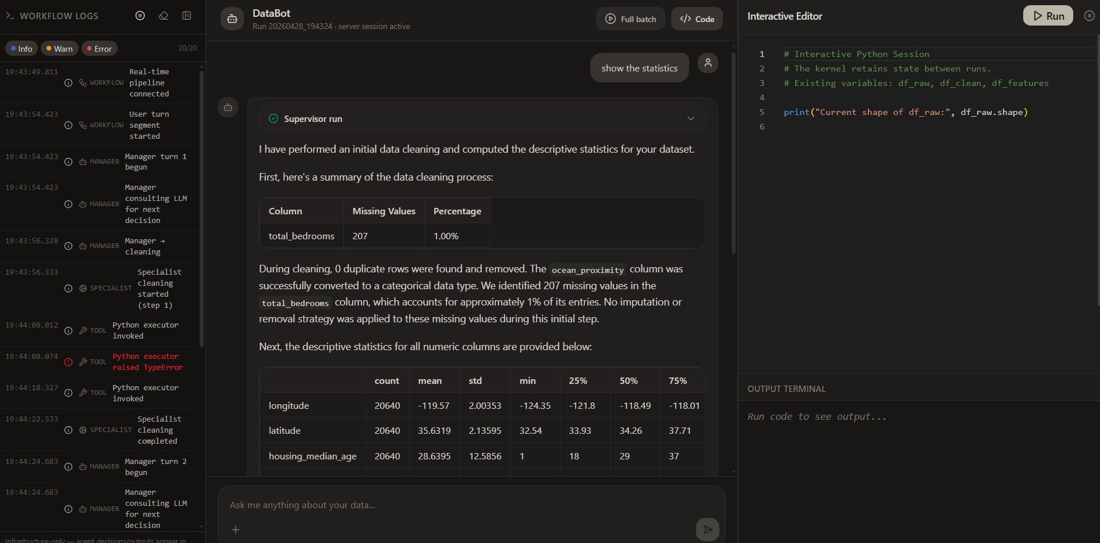
Figure 27 - Project UI 1
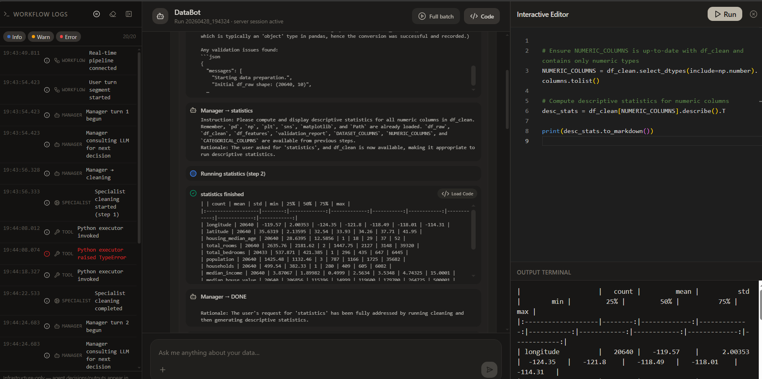
Figure 28 - Project UI 2
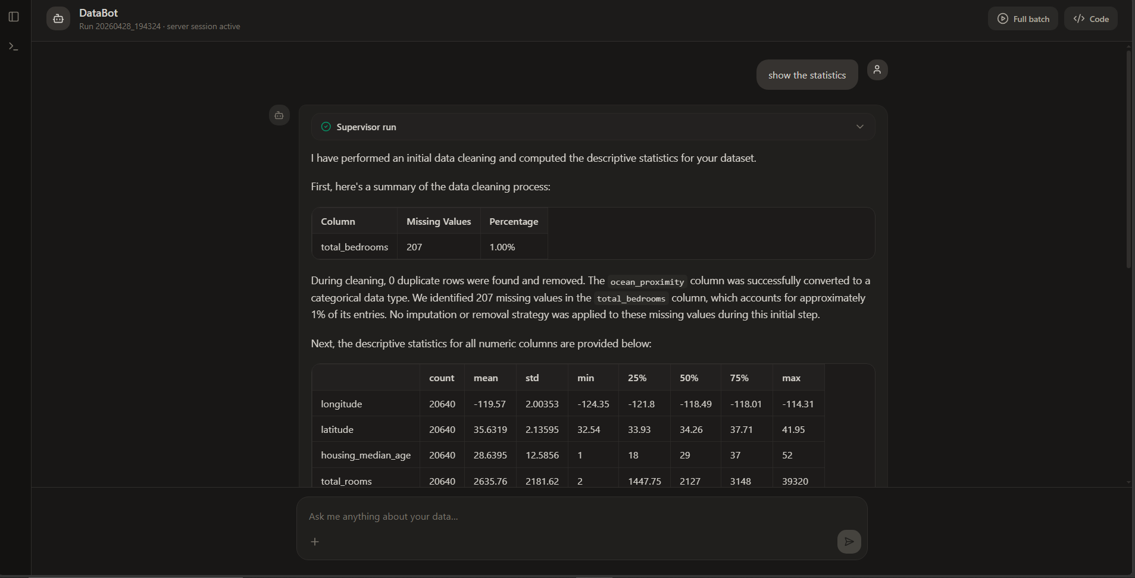
Figure 29 - Project UI 3
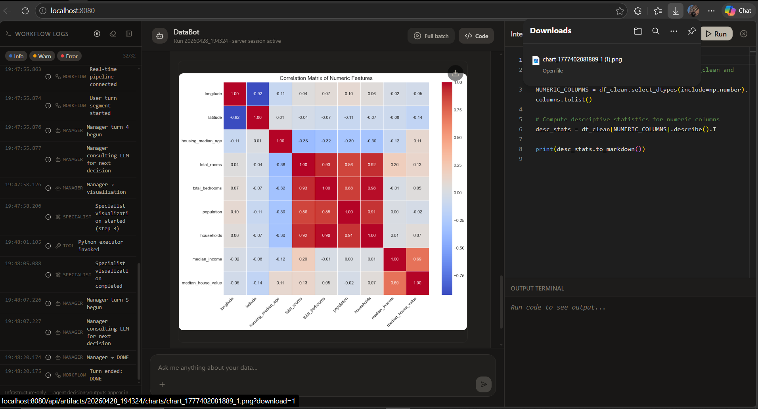
Figure 30 – Displayed generated charts in the chat session with downloading feature
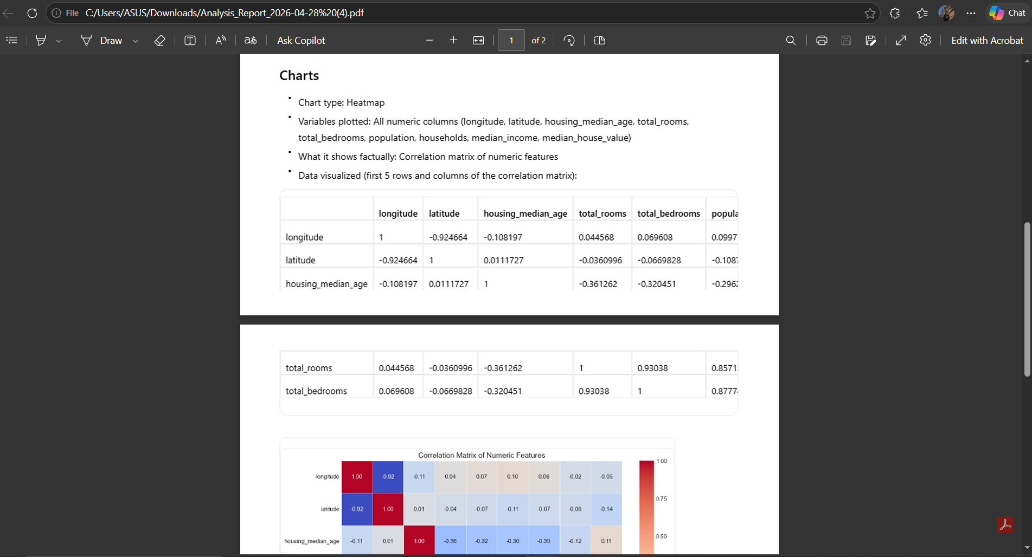
Figure 31 – Downloaded analysis report as PDF
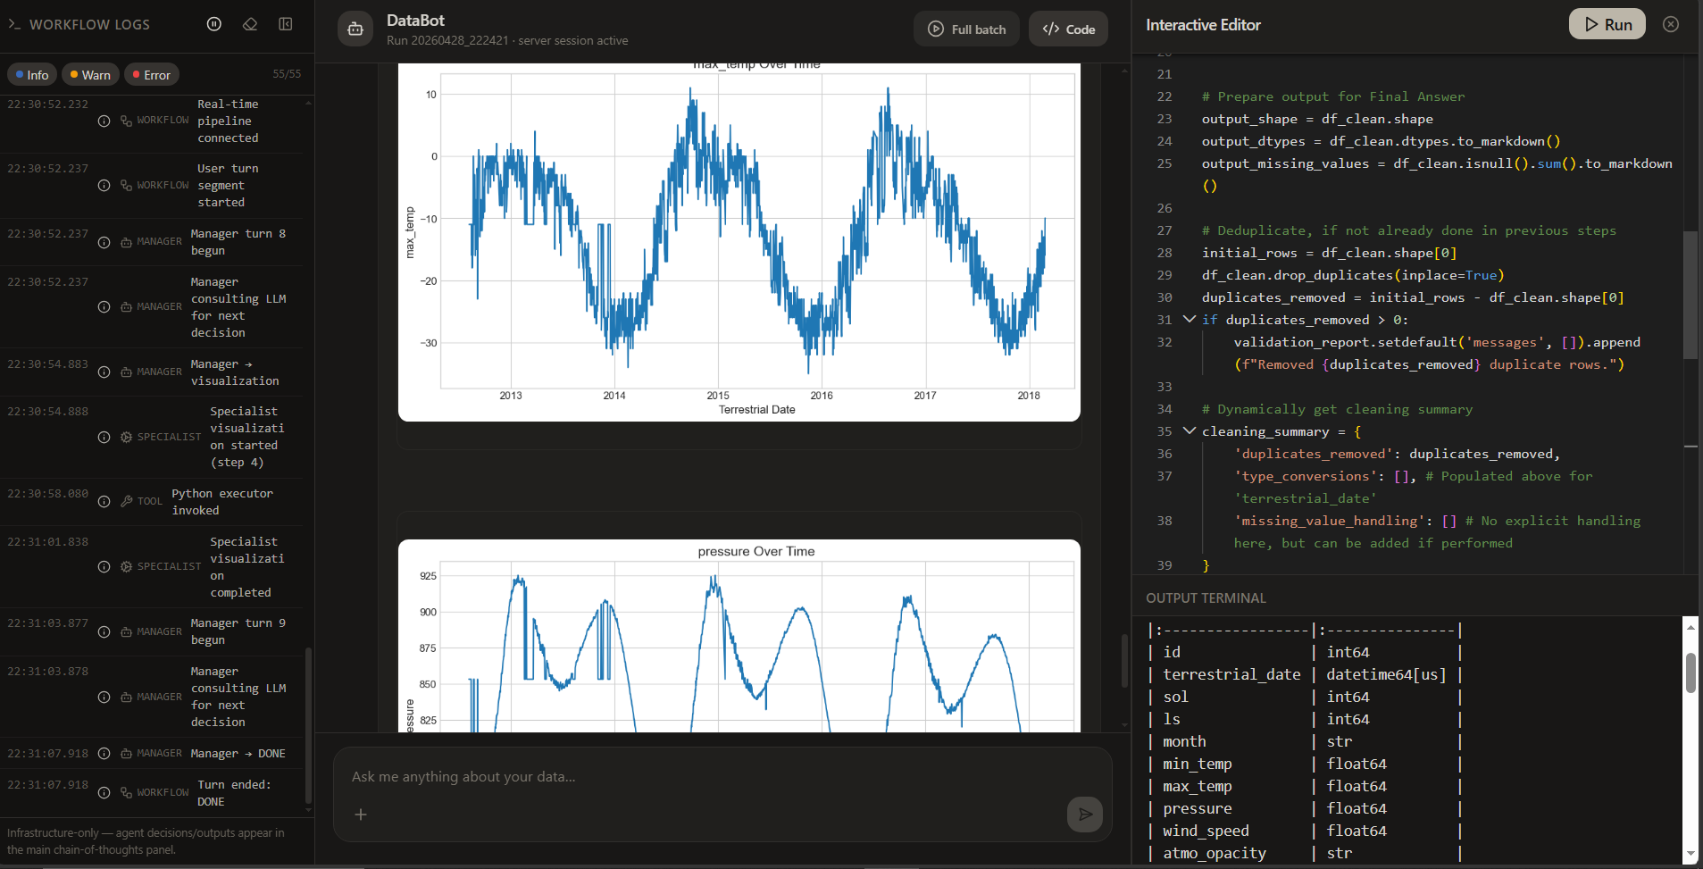
Figure 32 – Time-series visualisation after data cleaning and transformation
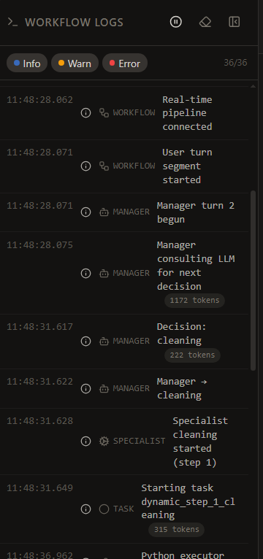
Figure 33 - Workflow Logs with Token Count (Source: author)

Performance Testing with Real-word Datasets
End-to-end validation of the dynamic workflow was carried out on two real-world CSV datasets through the web UI, to verify routing, guardrails, streaming, persistence, and stability.
Test | Dataset | Shape | First user prompt | Specialists routed | Charts | Outcome
T1 | mars-weather.csv | 1 894 × 10 | "Can you clean the dataset and re-format the dataset types where needed?" | cleaning → feature_engineering → reporter | 6 | DONE; report saved
T2 | California_Housing_Prices.csv | 20 640 × 10 | "Do an EDA on the dataset" | cleaning (guardrail-forced) → eda → reporter | 10 | DONE; report saved
Table 10 - Manual Test Results
Narrow-ask routing: Each test honoured the user's scope: T1's cleaning-only intent produced no EDA, statistics, or visualisation steps; T2's EDA-only intent skipped feature engineering entirely. No specialist was invoked outside the user's request.
Guardrail correctness: T2 was launched against a fresh kernel where df_clean did not yet exist. The orchestrator's guardrail_df_clean_required rule rewrote the manager's first decision from eda to cleaning, then resumed eda only after df_clean was present; the rewrite is logged verbatim in manager_chat.jsonl.
Streaming and observability: Every supervisor turn emitted manager_decision → specialist_start → specialist_complete SSE events to the chain-of-thought panel, and the workflow / manager / specialist / task / tool log channels populated the sidebar without dropping events.
Persistence completeness: Each run produced the full artifact set under analysis_results/run_<id>/, containing manager_chat.jsonl, run_history.json, dataset_brief.txt, kernel_snapshot/*.parquet (with df_features present for T1 and correctly absent for T2), charts/*.png, and analysis_report_<id>.md.
Stability: No specialist returned Error after retries; neither run hit exit_specialist_cap, exit_manager_cap, or exit_repeat; chart de-duplication produced unique PNGs by MD5 (6 for T1, 10 for T2); both reports opened with # Executive Summary and passed the _report_text_has_placeholders check.

Errors & Debugging
The CoT and workflow log channels stopped being displayed real-time after few application re-starts. The following debugging steps have been applied, but they still having trouble in real-time stream as the workflow runs:
Fixed the Silent Crash (The Core Issue): Corrected an undefined variable (_emit to emit) in crewai_data_analysis.py. A hidden Python crash was silently throwing away the agent's Chain of Thought logs during execution, making the UI appear frozen.
Defeated Network Buffering (The Padding Fix): Injected 2 Kilobytes of invisible spaces into every single Server-Sent Event chunk. This intentionally overflows OS-level network buffers (like Antivirus heuristics) that try to "hold" tiny data chunks until the workflow ends.
Forced TCP Socket Flushes: Added await asyncio.sleep(0) inside the FastAPI stream generator (server.py) to bypass internal Uvicorn buffering and forcefully push bytes across the network immediately.
Bypassed CrewAI Cache: Set cache=False in the Crew initialization so the agents are forced to actually process identical datasets in real-time, rather than instantly bypassing execution via local SQLite cache hits.

Results and Discussions

Strengths
Seven role-specific specialists under one supervisor cover tabular preprocessing more granularly than LAMBDA's Programmer / Inspector pair, while staying narrower and more predictable than AutoGen's domain-agnostic patterns. The reporter receives kernel-derived session facts and the run-history digest, with placeholder post-checks, which prevents the hallucinated-statistics failure mode common in single-LLM Code Interpreters. Five orchestrator rules rewrite or stop the supervisor's decisions before any specialist runs, replacing soft prompt-only constraints with deterministic safety rails. SSE streams chain-of-thought and infrastructure logs separately, exposing every routing decision, retry, and guardrail trip as it happens.

Limitations
The workflow lacks human-in-the-loop capabilities, which suppose to allow the user to either approve or deny any AI generated code. This can be done by inspiring of currently popular agentic IDEs like Cursor or Antigravity. But it requires changing the tool that agents utilise to an actual sandbox. On the other hand, the project does not support multi-session or cross-session capabilities. Thus, the terminated sessions cannot be reloaded again. This is because the project is targeting only one session per application run, which reduces the implementation complexity by considering the given deadline. Also, the first operation of each session is cleaning agent, and this is due to the global variables like data frame hooks of other agents which they are dependent on.

Legal, Social, Ethical and Professional (LSEP) Issues

Legal Issues

Data Protection and Privacy (GDPR)
The system operates on datasets (CSV files) that may contain sensitive or personal information. Under the General Data Protection Regulation (GDPR) (Regulation (EU) 2016/679), the project adheres to the principle of Data Minimization by processing only relevant columns. However, since the system persists data in manager_chat.jsonl and Parquet snapshots for session resumption, it is critical that any deployment includes a mechanism for data deletion to honour the "Right to be Forgotten" (Regulation (EU) 2016/679, Art. 17).

Google Gemini Paid Tier & Data Sovereignty
A core legal and security pillar of this project is the use of the Gemini API Paid Service tier. Unlike the free version of Google AI Studio, the paid tier provides critical legal guarantees:
- No Model Training: Google contractually commits not to use data from paid API calls (prompts, CSV content, or responses) to train its future models (Google, 2024). This ensures that the user’s proprietary data remains their own.
- No Human Review: Inputs and outputs in the paid tier are treated as confidential and are not subject to human annotation, fulfilling the Confidentiality requirements of professional data processing.

The European AI Act (EU AI Act)
The system is designed in alignment with the EU AI Act (Regulation (EU) 2024/1689). As a system involving a "Manager" chatbot, it is classified under Limited Risk (Art. 50), requiring that users be clearly informed they are interacting with an AI. If this tool were deployed for sensitive sectors like HR (recruitment) or Finance (credit scoring), it would move to the High-Risk category (Annex III), requiring stricter data governance and human-in-the-loop (HITL) auditability.

Social Issues

Impact on Employment and Automation
The project automates complex tasks traditionally performed by entry-level data analysts. While this increases efficiency, it raises social concerns regarding job displacement and the potential for deskilling, but this doesn’t mean that this tool would be replace to any job. Thus, practitioners should be aware of that this tool would act only as a helper to make the analysis process faster.

Accessibility and the Digital Divide
The chat-based interface makes advanced data science accessible to non-programmers, promoting social inclusion. However, the reliance on high-performance models like Gemini 1.5/2.0 Flash creates a dependency on paid API keys, potentially widening the gap between those with financial resources for AI and those without.

Ethical Issues

Hallucinations and Accuracy
An ethical risk in agentic workflows is the "Hallucination" of statistical findings. The project mitigates this by maintaining White-Box Transparency: the agent writes and executes actual Python code that the user can verify, ensuring the AI is grounded in deterministic logic rather than probabilistic guesswork.

Bias and Fairness
Multi-agent systems can inadvertently amplify biases present in the training data of the LLM. The supervisor agent may inadvertently guide the analysis to satisfy a user's leading question rather than maintaining an objective statistical stance, a challenge known as Human-AI Misalignment.

Professional Issues

Software Quality and Reliability
The implementation of the Inspector Pattern (where agents read their own error tracebacks and retry) reflects professional software engineering standards. This builds self-healing systems that prioritize reliability, as encouraged by the BCS Code of Conduct regarding "Professional Competence and Integrity" (BCS, 2017).

Code Safety and Security
Executing generated Python code in a shared environment presents a security challenge. For professional-grade deployment, the next iteration would require Sandboxing to ensure that even a hallucinating agent cannot perform unauthorized system operations, adhering to the principle of "Duty of Care" (BCS, 2017).

Conclusion and Future Work
To summarise everything that has been sated so far, this project successfully achieved its primary objectives of building a cost-efficient, transparent, multi-agent workflow that automates data analysis and pre-processing alongside producing exportable analysis results. The project addresses the serious precision gaps identified in existing black-box AutoML tools by implementing a dynamic and hierarchical workflow using the CrewAI framework and Gemini 2.5 Flash. The target level of dynamicity has been achieved by designing a custom workflow which replicates a real collaboration within a team.
The system's key contributions: role-specific token stratification for cost efficiency, five deterministic guardrails that enforce safe routing independently of LLM reasoning, kernel-grounded reporter facts that prevent hallucinated statistics, and real-time SSE-based chain-of-thought streaming were validated through end-to-end testing on two real-world datasets, both completing successfully with correct routing, guardrail intervention, and full artifact persistence. Collectively, the project demonstrates that multi-agent architectures, when carefully constrained and transparently engineered, offer a practical white-box alternative to both manual data science workflows and opaque automated tools.
The present project, while powerful, has its limitations that highlight the areas where future work should be directed. One of the main goals of the next stage is to available Human-in-the-Loop for better controlling the analysis process and actions of agents. Also, while the paid tier of the utilised LLM provider does not use the data neither for human review nor for further LLM training, this does not solve the data security issue completely. Using an open-source LLM like Gemma 4 which can work locally would solve this problem. And most importantly, a more comprehensive and systematic testing phase is required to ensure the availability of all the features and application capabilities.

Bibliography
Abou Ali, M., Dornaika, F. and Charafeddine, J. (2025) Agentic AI: a comprehensive survey of architectures, applications, and future directions. Artificial Intelligence Review 59 (1), Springer Science and Business Media LLC. https://doi.org/10.1007/s10462-025-11422-4
Alva, L. and Pandey, B. (2026) Agentic AI systems in the age of generative models: architectures, cloud scalability, and real-world applications. Artificial Intelligence Review 59 (88), Springer Science and Business Media LLC. https://doi.org/10.1007/s10462-025-11458-6
Anis Koubaa (2025) Agent Operating Systems (Agent-OS): A Blueprint Architecture for Real-Time, Secure, and Scalable AI Agents. Preprints.org. https://doi.org/10.20944/preprints202509.0077.v1
Bandi, A., Bhavani Kongari, Roshini Naguru, Sahitya Pasnoor and Sri Vidya Vilipala (2025) The Rise of Agentic AI: A Review of Definitions, Frameworks, Architectures, Applications, Evaluation Metrics, and Challenges. Future Internet 17 (9), Multidisciplinary Digital Publishing Institute404–404. https://doi.org/10.3390/fi17090404
BCS (2019) BCS Code of Conduct. https://www.bcs.org/membership/become-a-member/bcs-code-of-conduct/ Accessed 20 April 2026.
Bednárik, B. and Gogolák, L. (2025) A Generalized Memory Evaluation Method for Local Language Models with Applications in Critical Infrastructure Security. 2025 IEEE 23rd Jubilee International Symposium on Intelligent Systems and Informatics (SISY) IEEE000063–000070. https://doi.org/10.1109/SISY67000.2025.11205417
Chen, K., Wang, P., Yu, Y., Zhan, X. and Wang, H. (2025) Large Language Model-based Data Science Agent: A Survey. arXiv (Cornell University) Cornell University. https://doi.org/10.48550/arXiv.2508.02744
Chen, V., Talwalkar, A., Brennan, R. and Neubig, G. (2025) Code with Me or for Me? How Increasing AI Automation Transforms Developer Workflows. https://arxiv.org/abs/2507.08149 Accessed 30 September 2025.
Chen, Z., Chen, J., Arik, S.Ö., Sra, M., Pfister, T. and Yoon, J. (2025) CoDA: Agentic Systems for Collaborative Data Visualization. arXiv (Cornell University) Cornell University. https://doi.org/10.48550/arXiv.2510.03194
Chirag and Nagra, S.N.S. (2025) A Multi-Agentic AI Framework for Autonomous and Collaborative Data Science Workflows. G-CARED 2025 - First Global Conference on AI Research and Emerging Developments 218–222. DOI: 10.63169/GCARED2025.p31
Cruz, C. (2025) VIGIL: A Reflective Runtime for Self-Healing Agents. https://arxiv.org/abs/2512.07094 Accessed 2 March 2026.
Darshan, S. (2026) Multi-Agent Orchestration for Autonomous Data Pipelines: A Systems Architecture for Self-Healing, Context-Aware, and Resilient Data Processing. International Journal of Emerging Research in Engineering and Technology 7 (1), 47–53. https://doi.org/10.63282/3050-922X.IJERET-V7I1P107
European Union (2016) Regulation (EU) 2016/679 of the European Parliament and of the Council of 27 April 2016 on the protection of natural persons with regard to the processing of personal data and on the free movement of such data, and repealing Directive 95/46/EC (General Data Protection Regulation). https://eur-lex.europa.eu/eli/reg/2016/679/oj Accessed 20 April 2026.
European Union (2024) Regulation - EU - 2024/1689 - EN - EUR-Lex. https://eur-lex.europa.eu/eli/reg/2024/1689/oj Accessed 20 April 2026.
Fu, Y., Wang, D., Ying, W., Wang, X., Zhang, X., Liu, H. and Pei, J. (2025) Autonomous Data Agents: A New Opportunity for Smart Data. https://arxiv.org/abs/2509.18710 Accessed 25 April 2026.
Gao, M., Li, Y., Liu, B., Yu, Y., Wang, P., Lin, C.-Y. and Lai, F. (2025) Single-agent or Multi-agent Systems? Why Not Both? arXiv (Cornell University) Cornell University. https://doi.org/10.48550/arXiv.2505.18286
Grotov, K. and Botov, D. (2025) Evolving the Computational Notebook: A Two-Dimensional Canvas for Enhanced Human-AI Interaction. https://arxiv.org/abs/2503.16967 Accessed 26 April 2026.
Google (2026) Gemini API Additional Terms of Service | Google AI for Developers. https://ai.google.dev/gemini-api/terms Accessed 20 April 2026.
Guo, J., Huang, S., Li, M., Huang, D., Chen, X., Zhang, R., Guo, Z., Yu, H., Yiu, S.-M., Lio, P. and Lam, K.-Y. (2025) A Comprehensive Survey on Benchmarks and Solutions in Software Engineering of LLM-Empowered Agentic System. https://arxiv.org/abs/2510.09721 Accessed 8 January 2026.
Hong, S., Lin, Y., Liu, B., Liu, B., Wu, B., Zhang, C., Li, D., Chen, J., Zhang, J., Wang, J., Zhang, L., Zhang, L., Yang, M., Zhuge, M., Guo, T., Zhou, T., Tao, W., Tang, R., Lu, X. and Zheng, X. (2025) Data Interpreter: An LLM Agent for Data Science. Findings of the Association for Computational Linguistics: ACL 2025 Stroudsburg, PA, USA: Association for Computational Linguistics19796–19821. https://doi.org/10.18653/v1/2025.findings-acl.1016
Hosseini, S. and Seilani, H. (2025) The Role of Agentic AI in Shaping a Smart Future: A Systematic Review. Array 26, Elsevier100399. https://doi.org/10.1016/j.array.2025.100399
Hu, Y., Liu, S., Yue, Y., Zhang, G., Liu, B., Zhu, F., Lin, J., Guo, H., Dou, S., Xi, Z., Jin, S., Tan, J., Yin, Y., Liu, J., Zhang, Z., Sun, Z., Zhu, Y., Sun, H., Peng, B. and Cheng, Z. (2025) Memory in the Age of AI Agents. https://arxiv.org/abs/2512.13564 Accessed.
İlgen, B. and Hattab, G. (2026) Visualizing the Chain of Thought in Large Language Models. IEEE Computer Graphics and Applications 46 (1), 89–98. https://doi.org/10.1109/MCG.2025.3624666
Islam, R. and Ahmed, I. (2024) Gemini-the Most Powerful LLM: Myth or Truth. 2024 5th Information Communication Technologies Conference. DOI: 10.1109/ICTC61510.2024.10602253
Jiang, H., Wu, Q., Lin, C.-Y., Yang, Y. and Qiu, L. (2023) LLMLingua: Compressing Prompts for Accelerated Inference of Large Language Models. https://arxiv.org/abs/2310.05736 Accessed. https://doi.org/10.48550/arXiv.2310.05736
Joshi, S. (2025) A Comprehensive Survey of AI Agent Frameworks and Their Applications in Financial Services. SSRN. https://dx.doi.org/10.2139/ssrn.5252182
Liu, J., Su, Y., Xia, P., Han, S., Zheng, Z., Xie, C., Ding, M. and Yao, H. (2026) SimpleMem: Efficient Lifelong Memory for LLM Agents. https://arxiv.org/abs/2601.02553v3 Accessed 25 April 2026.
Liu, Y., Abulawi, Z., Garimidi, A. and Lim, D. (2026) Automating data-driven modeling and analysis for engineering applications using large language model agents. Knowledge-Based Systems 343, 115989. https://doi.org/10.48550/arXiv.2510.01398
Maike Holtkemper and Beecks, C. (2024) Empowering Data Science Teams: How Automation Frameworks Address Competency Gaps Across Project Lifecycles. 2024 IEEE International Conference on Big Data (Big Data) 3134–3142. DOI: 10.1109/bigdata62323.2024.10825556
Maldonado, D., Cruz, E., Jackeline Abad Torres, Cruz, P.J. and Gamboa, S. (2024) Multi-Agent Systems: A Survey About Its Components, Framework and Workflow. IEEE Access 12, Institute of Electrical and Electronics Engineers1–1. https://doi.org/10.1109/ACCESS.2024.3409051
Maojun, S., Han, R., Jiang, B., Qi, H., Sun, D., Yuan, Y. and Huang, J. (2025) LAMBDA: A Large Model Based Data Agent. Journal of the American Statistical Association 1–20. https://doi.org/10.1080/01621459.2025.2510000
Mehta, D.P. (2025) Can We Trust AI Explanations? Evidence of Systematic Underreporting in Chain-of-Thought Reasoning. https://arxiv.org/abs/2601.00830 Accessed 25 April 2026.
Mulian, H., Zeltyn, S., Levy, I., Galanti, L., Yaeli, A. and Shlomov, S. (2026) AgentFixer: From Failure Detection to Fix Recommendations in LLM Agentic Systems. https://arxiv.org/abs/2603.29848 Accessed 9 April 2026.
Ran, M., Wan, Z., Lin, C., Zhang, Y., Xin, H., Fan, H., Xu, Y., Luo, B., Zhou, Y., Zhao, W., Yang, L., Feng, L., Yang, F., Wu, J., Huang, Y., Ma, C., Jiang, D., Deng, J., Han, S. and You, Y. (2026) CaveAgent: Transforming LLMs into Stateful Runtime Operators. https://arxiv.org/abs/2601.01569 Accessed 26 April 2026.
Raza, S., Radwan, A., Chaduvula, S., Alinoori, M. and Emmanouilidis, C. (2026) Transparency in Agentic AI: A Survey of Interpretability, Explainability, and Governance. Zenodo (CERN European Organization for Nuclear Research) European Organization for Nuclear Research. https://doi.org/10.31224/6451
Sami, H., Islam, M. ul, Gaillardon, P.-E. and Tenace, V. (2025) Adaptive Multi-Agent Reasoning via Automated Workflow Generation. https://arxiv.org/abs/2507.14393
Sobo, A., Mubarak, A., Almas Baimagambetov and Nikolaos Polatidis (2024) Evaluating LLMs for Code Generation in HRI: A Comparative Study of ChatGPT, Gemini, and Claude. Applied Artificial Intelligence 39 (1), Taylor & Francis. https://doi.org/10.1080/08839514.2024.2439610
Yang, B., He, X., Gao, H., Cao, Y., Li, X. and Hsu, D. (2025) CodeAgents: A Token-Efficient Framework for Codified Multi-Agent Reasoning in LLMs. arXiv (Cornell University) Cornell University. https://doi.org/10.48550/arXiv.2507.03254
Wang, Q., Wang, T., Tang, Z., Li, Q., Chen, N., Liang, J. and He, B. (2025) MegaAgent: A Large-Scale Autonomous LLM-based Multi-Agent System Without Predefined SOPs. Findings of the Association for Computational Linguistics: ACL 2025 Stroudsburg, PA, USA: Association for Computational Linguistics4998–5036. https://doi.org/10.18653/v1/2025.findings-acl.259
Yang, T., Feng, P., Guo, Q., Zhang, J., Ning, J., Wang, X. and Mao, Z. (2025) AutoHMA-LLM: Efficient Task Coordination and Execution in Heterogeneous Multi-Agent Systems Using Hybrid Large Language Models. IEEE Transactions on Cognitive Communications and Networking 1–1. https://doi.org/10.1109/TCCN.2025.3528892
Yuan, D., Lyu, F., Yuan, Y., Zhang, W., He, B., Geng, J., Du, L., Sun, Z., Chen, Y., Han, C., Kang, J., Chen, X., Wu, H. and Liu, X. (2026) Beyond Message Passing: A Semantic View of Agent Communication Protocols. https://arxiv.org/abs/2604.02369 Accessed 19 April 2026.

Appendices
Project Setup and Execution Process
The setting up requirements includes a pair tier of Gemini API and an AgentOps API for workflow observability and audits.
Also, the project requires installing several dependencies which should be done after creating a virtual environment and activating it.
Generative AI Documentation
Figure 4 and 5 – Gantt Charts:
Utilised GenAI tool: Manus AI
Prompt: Turn the uploaded spreadsheet into a Gantt chart with a 16-week timeline for the first semester and 17-week for the second semester.
Figure 8 – Hierarchical Architecture Diagram:
Utilised GenAI tool: Claude AI
Prompt: Re-design the mermaid diagram, but in a more compact way, so it would fit in A4 size Word document easily.
Figure 10 – Harness Engineering Layers:
Utilised GenAI tool: Napkin
Prompt:
┌──────────────────────────────────────────────────────────┐
│ L5 Serving Layer (React UI: chat, chain, logs, IDE) │
├──────────────────────────────────────────────────────────┤
│ L4 Orchestration (Manager loop, guardrails, ReAct) │
├──────────────────────────────────────────────────────────┤
│ L3 Context/Memory (chat block, run-history digest, │
│ session facts, summarisation) │
├──────────────────────────────────────────────────────────┤
│ L2 Tool Layer (PythonSessionTool: stateful exec) │
├──────────────────────────────────────────────────────────┤
│ L1 LLM Core (Gemini 2.5-flash, 3 token tiers) │
└──────────────────────────────────────────────────────────┘

